
KENYATTA UNIVERSITY

SCHOOL OF PURE AND APPLIED SCIENCES

MATHEMATICS AND ACTUARIAL SCIENCE DEPARTMENT

SAC 407 – PROJECT IN ACTUARIAL SCIENCE
Modelling Motor Vehicle Insurance Claims in Kenya Using a Frequency-Severity Approach for Risk-Based Premium Estimation

BY

KARANJA WAMBURA BRENDA – I162/3917/2022
JEPTOO JUNE – I162/0723/2022
JUNIOR JOEL – I162/4837/2022
MWANGI KIBOI BRADON – I162/0715/2022
MWANGI KAGUCIA – I162/0713/2022

MARCH 2025

This project is submitted for the partial fulfillment of the requirements for the award of the degree of Bachelor of Science (Actuarial Science) in the Education of Lifelong Learning of Kenyatta University.

Acknowledgement
Recognize the persons to whom the author(s) are indebted for guidance and assistance. Acknowledges those who have helped him/her in the writing of the project. •

Dedication
Includes the names of the person/persons for whom the project was written.

Table of Contents
Abstract 1
CHAPTER 1 2
INTRODUCTION 2
1.0 Introduction 2
1.2 Statement of the Problem 4
1.3 Objectives of the Study 5
1.3.1 General Objective 5
1.2.2 Specific Objectives 5
1.3 Justification and Significance of the Study 6
CHAPTER TWO 8
LITERATURE REVIEW 8
2.1 Introduction 8
2.2 Motor Insurance Claim Modelling and Premium Estimation 8
2.3 Claim Frequency Modelling 8
2.4 Claim Severity Modelling 9
2.5 Frequency-Severity Modelling and Dependence 10
2.6 Alternative and Machine-Learning Approaches 10
2.7 Synthesis of Existing Literature and Research Gap 11
CHAPTER THREE 13
METHODOLOGY 13
3.1 Introduction 13
3.2 Research Design and Sampling Method 13
3.3 Description and Assessment of the Data 13
3.4 Data Preparation and Selection 15
3.6 Description of the Frequency Model 18
3.7 Description of the Severity Model 20
3.8 Frequency-Severity Pure Premium Model 22
3.9 Summary of Proposed Models 23
3.10 Model Assumptions 24
3.11 Model Estimation and Evaluation 25
3.12 Methodological Limitations Arising from the Data 26
Chapter 4 28
DATA ANALYSIS AND RESULTS 28
4.1 Introduction 28
4.2 Data Preparation Results 28
4.3 Descriptive Analysis of Claim Frequency 28
4.4 Descriptive Analysis of Claim Severity 30
4.5 Descriptive Analysis of Explanatory Variables 31
CHAPTER FOUR 33
RESULTS AND FINDINGS 33
4.1 Introduction 33
4.2 Data Preparation Results 33
4.3 Descriptive Results for Claim Frequency 34
4.4 Descriptive Results for Claim Severity 34
4.5 Descriptive Characteristics of the Explanatory Variables 36
4.6 Claim Frequency Model Results 37
4.7 Frequency Model Comparison and Diagnostics 38
Figure 4.5: Residuals versus Predicted Claim Frequency: ZTNB 39
4.8 Claim Severity Model Results 40
4.9 Severity Model Comparison and Diagnostics 41
4.10 Factors Influencing Claim Frequency and Severity 43
4.11 Pure Premium Estimation 44
4.12 Pure Premium Differentiation Across Risk Profiles 45
4.13 Evaluation and Summary of Findings 47
CHAPTER FIVE 49
CONCLUSIONS AND RECOMMENDATIONS 49
5.1 Conclusions 49
5.2 Recommendations 49
5.3 Areas for Future Research 50
References 51

List of Figures
Figure 1: Data Preparation and Analysis Workflow
Figure 2: Frequency-Severity Framework for Pure Premium Estimation
Figure 3: Distribution of Claim Frequency Among Claimant Policies
Figure 4: Distribution of Gross Paid for Settled Claims
Figure 5: Boxplot of Gross Paid for Settled Claims
Figure 6: Distribution of Settled Motor Claim Severity
Figure 7: Boxplot of Settled Motor Claim Severity
Figure 8: Residuals versus Predicted Claim Frequency: ZTP
Figure 9: Residuals versus Predicted Claim Frequency: ZTNB
Figure 10: Residuals versus Predicted Claim Frequency: ZTNB
Figure 11: Residuals versus Predicted Claim Severity: Gamma GLM
Figure 12: Residuals versus Fitted Values: Lognormal Model
Figure 13: Normal Q-Q Plot of Log-normal Residuals
Figure 14: Distribution of Estimated Pure Premiums

List of Tables
Table 1: Summary of Selected Empirical Studies on Frequency-Severity Modelling
Table 2: Description and Analytical Use of Main Study Variable
Table 3: Distribution of Claim Frequency Among Observed Policies
Table 4: Distribution of Claims by Claim Status
Table 5: Distribution of Claims by Claim Status
Table 6: Summary of the Statistical Modelling Framework
Table 7: Summary of Data Preparation and Analytical Samples
Table 8: Descriptive Statistics for Claim Frequency
Table 9: Distribution of Claim Frequency Among Claimant Policies
Table 10: Descriptive Statistics for Severity
Table 11: Descriptive Summary of Rating Variables
Table 12: Summary of Analytical Samples
Table 13: Observed Claim Frequency Distribution
Table 14: Descriptive Statistics for Settled Claim Severity
Table 15: Distribution of Claimant Policies by Vehicle Type
Table 16: Selected ZTNB Frequency-Model Estimates
Table 17: Comparison of Frequency Models
Table 18: Selected Gamma GLM Severity-Model Estimates
Table 19: Comparison of Severity Models
Table 20: Summary of Estimated Pure Premiums
Table 21: Estimated Pure Premiums by Vehicle Type
Table 22: Locations with the Highest Mean Estimated Pure Premiums
Table 23: Representative Pure-Premium Profiles

Abstract

CHAPTER 1

INTRODUCTION

1.0 Introduction
Motor vehicle insurance is an important component of the general insurance industry because it provides financial protection against losses associated with road accidents, theft, property damage, third-party liabilities, and other insured motor risks. From an actuarial perspective, the sustainability of motor insurance depends substantially on an insurer's ability to estimate the expected cost of future claims and charge premiums that appropriately reflect the underlying risk. Premium estimation is therefore an important component of insurance pricing because inadequate premiums may expose insurers to underwriting losses, while excessively high premiums may reduce affordability and result in inequitable pricing among policyholders.
Motor insurance occupies a significant position within Kenya's general insurance market. The Association of Kenya Insurers (AKI) reported that Motor Private generated gross written premiums of approximately KES 28.55 billion in 2022, while Motor Commercial generated approximately KES 26.66 billion. Together, the two classes generated approximately KES 55.21 billion in gross written premiums during the year (Association of Kenya Insurers [AKI], 2022). Despite this substantial premium income, the two motor insurance classes recorded a combined underwriting loss of approximately KES 6.96 billion in 2022. Motor Private accounted for an underwriting loss of approximately KES 4.00 billion, while Motor Commercial recorded a loss of approximately KES 2.97 billion (AKI, 2022).
Profitability pressures continued in subsequent periods. According to AKI (2023), Motor Private insurance recorded a combined ratio of 96.6%, while Motor Commercial insurance recorded a combined ratio of 101.0%. Motor and medical insurance were identified among the leading loss-making classes in Kenya's general insurance market. A combined ratio close to or above 100% indicates that a substantial proportion, or potentially all, of insurance revenue is being absorbed by claims and related insurance service expenses, demonstrating the financial importance of accurately assessing and pricing motor insurance risk.
Recent regulatory statistics provide further evidence of this continuing challenge. During the third quarter of 2024, Motor Private insurance recorded an underwriting loss of approximately KES 1.12 billion, while Motor Commercial insurance recorded a loss of approximately KES 1.63 billion. These were the two largest underwriting losses among the general insurance classes reported during the period (Insurance Regulatory Authority [IRA], 2024). The continuing underwriting pressure within the motor insurance market emphasizes the need for actuarial pricing approaches capable of reflecting differences in expected claim costs across different categories of insured risks.
An insurer's expected claim cost is influenced by two fundamental components: claim frequency and claim severity. Claim frequency represents how often claims are expected to occur, while claim severity represents the expected financial cost of a claim when it occurs. These two components may be influenced differently by policyholder and vehicle characteristics. For example, characteristics associated with a higher probability of experiencing claims may not necessarily be the same characteristics associated with larger claim amounts. Consequently, analyzing total claims expenditure alone may conceal important differences between the processes driving the occurrence of claims and those driving their financial magnitude.
The frequency-severity approach provides an actuarially intuitive framework for separating these two components. Claim frequency is modelled independently from claim severity, after which their expected values are combined to estimate the expected claims, cost associated with a particular risk profile. In its basic form, the relationship can be expressed as:
E(N) times E(X), where (E(N)) represents the expected claim frequency and (E(X)) represents the expected claim severity. The resulting pure premium represents the expected cost of claims before the addition of expenses, commissions, taxes, profit margins, and other commercial premium loadings.
This approach is particularly useful for motor insurance because policyholders and vehicles have heterogeneous risk characteristics. Factors such as driver age, vehicle age, vehicle type, vehicle value, geographical location, and sum insured may be associated with differences in claim experience. A frequency-severity modelling framework therefore provides an opportunity to quantify these relationships separately and subsequently combine them to obtain risk-differentiated estimates of expected claims cost.
This study applies a frequency-severity framework to motor vehicle insurance claims in Kenya. The study will examine the characteristics associated with differences in claim frequency and severity, develop suitable statistical models for each component, and integrate the predicted components to obtain pure premium estimates. The approach is intended to provide an understandable and systematic actuarial framework for analyzing motor insurance claims and demonstrating how observable risk characteristics can be incorporated into premium estimation.
.

Statement of the Problem
Motor vehicle insurance is an important class of general insurance in Kenya, providing financial protection against losses arising from road accidents, theft, and other insured risks. However, the motor insurance sector continues to experience substantial claims costs and underwriting profitability challenges. According to the Insurance Regulatory Authority (IRA), Motor Private and Motor Commercial insurance recorded underwriting losses of approximately KES 1.12 billion and KES 1.63 billion, respectively, during the third quarter of 2024, making them the two general insurance classes with the highest underwriting losses during the period (Insurance Regulatory Authority [IRA], 2024). The two motor classes also accounted for 40.7% of claims incurred under general insurance despite contributing only 26.5% of general insurance premium business. Similarly, the Association of Kenya Insurers reported underwriting losses of approximately KES 4.0 billion for Motor Private and KES 3.0 billion for Motor Commercial insurance in 2022 (Association of Kenya Insurers [AKI], 2022). These patterns demonstrate the significant financial pressure associated with motor insurance claims in Kenya.
Accurate premium estimation is therefore important for ensuring that premiums adequately reflect expected claims costs across different risk profiles. Motor insurance losses arise from two distinct components: the frequency with which claims occur and the severity of losses when claims occur. Premium estimation approaches that do not adequately distinguish between these components may fail to capture the different factors influencing claim occurrence and claim cost, potentially contributing to inadequate risk differentiation and premium mispricing. The continuing profitability pressures in the Kenyan motor insurance market reinforce this concern. In 2023, Motor Private and Motor Commercial insurance recorded combined ratios of approximately 96.6% and 101.0%, respectively, indicating that claims and related insurance service expenses consumed a substantial proportion of insurance revenue (AKI, 2023).
Although frequency-severity modelling is well established internationally as an actuarial approach to insurance ratemaking, comparatively limited published empirical evidence has applied this framework within the Kenyan motor insurance context. There is therefore a need for an actuarial approach that separately examines the factors influencing claim frequency and claim severity and subsequently combines the two components to estimate expected claims costs. This study seeks to address this need by developing a frequency-severity modelling framework for motor vehicle insurance claims in Kenya, with the aim of supporting more systematic, risk-sensitive, and sustainable pure premium estimation.
.

1.3 Objectives of the Study

1.3.1 General Objective
To develop and evaluate a frequency-severity model for estimating pure premiums using motor vehicle insurance claims data from a Kenyan insurer.

1.2.2 Specific Objectives
- To analyze the factors influencing motor vehicle insurance claim frequency in the available Kenyan motor insurance claims experience.
- To develop and evaluate a zero-truncated count regression model for predicting motor vehicle insurance claim frequency among claimant policies.
- To analyze the factors influencing motor vehicle insurance claim severity in the available Kenyan motor insurance claims experience.
- To develop and evaluate a Gamma Generalized Linear Model for predicting the severity of settled motor vehicle insurance claims and compare its performance with a Lognormal model.
- To estimate risk-differentiated pure premiums by combining the predicted claim frequency and claim severity using a frequency-severity framework.
- To evaluate the suitability and predictive performance of the proposed frequency-severity framework for pure premium estimation using the available Kenyan motor insurance claims experience.

1.3 Justification and Significance of the Study
Accurate premium estimation is essential to the financial sustainability of insurance operations because premiums must be sufficient to meet expected claims while remaining appropriate to the level of risk represented by different policyholders. This is particularly important in Kenya's motor insurance market, where persistent underwriting losses and high combined ratios indicate continuing pressure on the profitability of Motor Private and Motor Commercial insurance. The substantial underwriting losses reported in recent industry reports demonstrate the practical importance of improving the understanding and estimation of motor insurance claim costs.
The study is actuarially justified because motor insurance losses arise from two distinct processes: the occurrence of claims and the financial cost of those claims. Separately modelling claim frequency and claim severity allows the factors associated with each process to be examined independently. Their predicted values can then be combined to estimate the expected claims cost, or pure premium. This provides a transparent approach to identifying risk differences and estimating premiums that more closely reflect expected claims experience.
The use of regression-based frequency and severity models is also justified because these models provide both predictive capability and interpretability. Rather than producing only a final premium estimate, the proposed approach allows the effects of selected driver, vehicle, and geographical characteristics on expected claim frequency and severity to be examined. This is important in actuarial pricing because pricing decisions should be supported by models whose assumptions and risk relationships can be explained and evaluated.
The study may be significant to insurers and actuaries by demonstrating a systematic framework for analyzing motor insurance claim experience and deriving risk-differentiated pure premium estimates. Underwriters and pricing professionals may also benefit from improved understanding of the characteristics associated with higher or lower expected claim costs. At an industry level, the findings may contribute to discussions on more sustainable and risk-sensitive pricing within the Kenyan motor insurance market.
The study also contributes to actuarial research by applying an established frequency-severity framework within the Kenyan motor insurance context. Much of the existing empirical literature has examined motor insurance markets outside Kenya or has employed more complex modelling techniques. The proposed approach therefore provides a locally relevant and interpretable application of actuarial frequency-severity modelling and may provide a foundation for future studies using broader policy-level datasets or alternative statistical and machine-learning approaches.

CHAPTER TWO

LITERATURE REVIEW

2.1 Introduction
Motor insurance pricing requires insurers to estimate future claim costs while accounting for differences in policyholder and vehicle risk characteristics. These costs are commonly divided into claim frequency, representing how often claims occur, and claim severity, representing the financial cost of claims, with the two components combined to estimate the pure premium. Actuarial research has widely applied Generalized Linear Models (GLMs) to model these outcomes because they can accommodate count data and positively skewed claim amounts, while more recent studies have explored dependence between frequency and severity and the use of machine-learning methods. This chapter reviews the main approaches to motor insurance frequency and severity modelling, their application to premium estimation, and recent developments in predictive modelling, while identifying limitations in existing research and the gap motivating an interpretable frequency-severity framework for motor insurance claims in Kenya.

2.2 Motor Insurance Claim Modelling and Premium Estimation
An important objective of non-life insurance pricing is to estimate premiums that reflect differences in expected claims experience across insured risks. Since policyholders and vehicles differ in both the likelihood of making claims and the cost of those claims, actuarial pricing models aim to identify the factors associated with these variations. The frequency-severity approach addresses this by modelling claim frequency and claim severity separately before combining them to estimate expected claims costs. Su and Bai (2020) describe this framework as a standard insurance modelling approach in which frequency represents the number of claims and severity represents the average claim amount, with policyholder, vehicle, and geographical characteristics used as predictors.
Tevet (2016) explains that the frequency-severity approach offers an interpretive advantage over direct pure-premium modelling because it separates the factors that influence how often claims occur from those that influence how costly claims become. This is particularly useful in motor insurance, where driver characteristics may affect claim occurrence while vehicle value or sum insured may have a stronger influence on claim severity. The framework therefore supports both premium estimation and a clearer understanding of the underlying sources of motor insurance risk.

2.3 Claim Frequency Modelling
Claim frequency is a count variable representing the number of claims associated with an insured risk over a given exposure period. Because claim counts are non-negative integers, ordinary linear regression is generally unsuitable. Poisson and Negative Binomial distributions are therefore commonly applied within Generalized Linear Model frameworks. The Poisson model assumes that the conditional mean and variance of claim counts are equal, while the Negative Binomial model allows the variance to exceed the mean through an additional dispersion parameter.
Covrig and Badea (2017) examined several GLMs for motor insurance claim frequency using data from a Romanian insurer. Their findings showed that the Negative Binomial model performed better than the Poisson model because it accounted for overdispersion in the observed claim counts. Their study demonstrates that the choice of frequency model should depend on the statistical characteristics of the data rather than assuming that one distribution is always superior.
Gilenko and Mironova (2017) also examined claim frequency and severity in the Russian motor own-damage insurance market. Their study considered the relationship between rating factors and claim experience and showed how statistical models can be used to assess whether existing tariff factors adequately represent underlying motor insurance risk. These studies support the use of GLMs for identifying relationships between observable policyholder or vehicle characteristics and claim frequency.
An additional issue arises when the available data excludes policies with zero claims. Standard Poisson and Negative Binomial models allow counts beginning at zero, while data containing only policies that have experienced at least one claim requires a zero-truncated count model. Such models condition the distribution on positive claim counts and are therefore more appropriate when zero-claim observations are absent. Ignoring this truncation may lead to misleading estimates and interpretations of claim frequency.

2.4 Claim Severity Modelling
Claim severity represents the monetary amount of an insurance claim and is usually continuous, positive, and right-skewed, with many moderate claims and fewer very large losses. Gamma regression is commonly used for severity because the Gamma distribution accommodates positive skewed values, while a log link ensures that predicted claim amounts remain positive. Su and Bai (2020) note that traditional frequency-severity models often combine Poisson or Negative Binomial models for frequency with Gamma or Inverse Gaussian models for severity, and their study also applied a Gamma model to average claim severity.
The Lognormal distribution is another widely used severity model because it can capture positively skewed claim amounts and heavier right tails. Under this approach, the logarithm of claim amounts is assumed to follow a normal distribution. Since both Gamma and Lognormal models can be appropriate for insurance losses, the choice between them should be based on the observed characteristics of the data and predictive performance rather than assuming that one model is always superior.
Clemente et al. (2023) compared traditional GLMs with Gradient Boosting Models for motor insurance frequency and severity. Although Gradient Boosting performed better for claim frequency, the classical GLM performed better for severity. This suggests that more complex models do not necessarily provide better results for every insurance outcome and supports comparing established actuarial severity models before adopting more advanced alternatives.

2.5 Frequency-Severity Modelling and Dependence
A basic frequency-severity model often assumes that claim frequency and claim severity are conditionally independent given the included risk characteristics. Under this assumption, the expected aggregate claims cost is expressed as E(S) = E(N) × E(X), where N represents claim frequency and X represents claim severity.
Frees et al. (2016) examined multivariate frequency-severity regression models and showed that insurance events may generate related outcomes that should not always be analyzed separately. Their work highlights the possibility that frequency and severity may be connected and that multivariate approaches can better represent these relationships.
Garrido et al. (2016) proposed a relatively simple way of introducing dependence within a GLM framework by including claim frequency as a covariate in the severity model. Lee et al. (2019) later examined this approach and noted that although it provides a simple way to represent dependence, the relationship between frequency and severity may be more complex than a single regression term can capture.
Overall, the literature shows that independence between claim frequency and severity should not be assumed automatically. However, more advanced dependence models, such as copula and shared random-effects models, can increase computational complexity and reduce interpretability. For this reason, a separate frequency-severity framework remains useful for applied actuarial pricing when the aim is to produce an understandable model of expected claim cost while clearly acknowledging its assumptions and limitations.

2.6 Alternative and Machine-Learning Approaches
Recent actuarial research has increasingly explored machine-learning methods as alternatives or complements to traditional Generalized Linear Models (GLMs). These methods can capture nonlinear relationships and complex interactions among rating variables without requiring all relationships to be specified in advance.
Su and Bai (2020) developed a stochastic gradient boosting frequency-severity model that allowed for nonlinear effects and dependence between claim frequency and severity. Applied to French automobile insurance data, their model produced stronger predictive results than the comparison models. Clemente et al. (2023) also compared Gradient Boosting with standard GLMs and found that Gradient Boosting performed better for claim frequency, while the classical GLM performed better for claim severity.
These findings show that machine-learning methods can improve prediction in some cases, but they also involve greater complexity and may be less interpretable. GLMs remain useful in actuarial pricing because their coefficients and rating effects are easier to explain. Therefore, a GLM-based framework may be preferable when the aim is to develop a transparent and understandable pricing model, while machine-learning methods can be considered in future research.

2.7 Synthesis of Existing Literature and Research Gap
The reviewed literature shows that claim frequency and claim severity are central to non-life insurance pricing. Poisson and Negative Binomial models are commonly used for claim frequency, while Gamma and Lognormal models are widely applied to claim severity. GLMs remain important because they combine statistical flexibility with relatively straightforward interpretation.
However, no single model is suitable in every situation. Covrig and Badea (2017) showed that Negative Binomial regression can outperform Poisson regression when overdispersion is present, while Gilenko and Mironova (2017) emphasized the importance of selecting relevant rating factors for both frequency and severity. Garrido et al. (2016) and Lee et al. (2019) further showed that claim frequency and severity may be dependent, meaning their relationship should be considered carefully.
Recent studies have also explored machine-learning approaches. Su and Bai (2020) found that Gradient Boosting can capture nonlinear relationships, interactions, and dependence between frequency and severity, while Clemente et al. (2023) showed that more complex models do not always perform better, as the traditional GLM performed better for claim severity in their study. This supports the continued use of interpretable actuarial models when they provide adequate predictive performance.
Most existing empirical studies have been conducted outside Kenya, creating a contextual gap in the application of frequency-severity models to Kenyan motor insurance. This study addresses that gap by using an interpretable frequency-severity framework that recognizes the structure of the available claims experience, compares suitable alternative models, and combines predicted claim frequency and severity to estimate pure premiums. The proposed approach therefore aims to balance statistical suitability, predictive performance, and actuarial interpretability.
Study | Insurance/Data Context | Frequency Method | Severity Method | Main Finding | Relevance/Gap
Frees et al. (2016) | Insurance | Multivariate regression | Multivariate severity | Frequency and severity may be related | Supports dependence consideration
Garrido et al. (2016) | Canadian automobile | GLM | GLM with frequency covariate | Allows dependence between frequency and severity | More complex than separate model
Gilenko & Mironova (2017) | Russian motor | Frequency models | Severity models | Rating variables influence claim experience | Non-Kenyan context
Covrig & Badea (2017) | Romanian motor | Poisson/NB | — | NB performed better with overdispersion | Supports data-based model choice
Lee et al. (2019) | Insurance | GLM | Conditional severity GLM | Dependence can be complex | Highlights limitations of simple dependence
Su & Bai (2020) | French automobile | Gradient Boosting | Gradient Boosting | ML captures nonlinear effects | Lower interpretability
Clemente et al. (2023) | Motor insurance | GLM/Gradient Boosting | GLM/Gradient Boosting | ML better for frequency, GLM better for severity | Complexity not always superior
Table 1: Summary of Selected Empirical Studies on Frequency-Severity Modelling

CHAPTER THREE

METHODOLOGY

3.1 Introduction
This chapter describes the methodology used to model motor vehicle insurance claim frequency and severity and combine the two components for pure premium estimation. It presents research design, source and selection of data, data preparation procedures, variables used in the analysis, ethical and confidentiality considerations, model specifications and assumptions, estimation procedures, and methods used to evaluate model performance. The study follows a quantitative frequency-severity framework in which claim frequency and claim severity are modelled separately before their predicted values are combined to estimate expected claims costs.

3.2 Research Design and Sampling Method
This study adopts a quantitative retrospective research design based on secondary motor vehicle insurance claims data obtained from a Kenyan insurance company. A retrospective design is appropriate because the study analyses historical claim records to investigate the relationship between observable risk characteristics, claim occurrence, and claim cost. The quantitative approach allows statistical models to be developed for claim frequency and claim severity and subsequently combined to estimate pure premiums.
We did not participate in the original collection of the insurance records. The company provided an existing claims dataset containing records generated through its normal insurance and claims-management processes. Consequently, no probability sampling procedure was designed by the researcher. Instead, all available records that satisfied the requirements for the relevant frequency or severity analysis were considered. The analysis therefore represents a census of the usable records contained in the dataset supplied by the insurer rather than a sample independently drawn from the insurer's entire policy portfolio.
The original dataset contains 107,566 claim records and 16 variables, with 69,327 unique policy identifiers. The recorded dates of loss cover the period from 2019 to 2024. Because the database is claim-based, all policies represented in the data have experienced at least one claim. This characteristic is particularly important in selecting an appropriate statistical model for claim frequency.

3.3 Description and Assessment of the Data
The dataset contains information on policy identification, claim identification, driver and vehicle characteristics, geographical characteristics, claim amounts, claim status, claim frequency, and claim dates. The main variables relevant to the study are summarized in Table 3.1.

Variable | Description | Variable Type | Proposed Analytical Role
Policy ID | Identifier for an insured policy | Identifier | Used to aggregate claims to policy level
Claim Number | Identifier for individual claim | Identifier | Record identification only
Claim Frequency | Number of claims associated with a policy | Count | Frequency response variable
Gross Paid | Amount paid in respect of a claim | Continuous | Severity response variable
Driver Age | Age of insured driver | Continuous | Predictor
Vehicle Age | Age of insured vehicle | Continuous | Predictor
Vehicle Type | Classification of insured vehicle | Categorical | Predictor
Vehicle Value | Value assigned to insured vehicle | Continuous | Frequency predictor
Sum Insured | Maximum insured value recorded | Continuous | Severity predictor
Location | Geographical location of insured risk | Categorical | Predictor
Population Density | Density associated with location | Continuous | Alternative geographical predictor
Claim Type | Nature of reported claim | Categorical | Descriptive analysis
Claim Status | Settlement status of claim | Categorical | Used in selecting severity observations
Date of Loss | Date on which loss occurred | Date | Used to derive loss year
Reporting Date | Date on which claim was reported | Date | Descriptive/data-quality analysis
Settlement Date | Date on which claim was settled | Date | Descriptive/data-quality analysis
Table 2: Description and Analytical Use of Main Study Variable
The dataset is considered useful for the study because it contains both claim-count and claim-payment information together with several driver, vehicle, and geographical characteristics. Its size also provides sufficient observations for regression-based modelling and model validation.
However, the data have several limitations that affect their use. First, the dataset contains only policies associated with at least one claim and therefore contains no zero-claim policies. Second, policy exposure, such as the exact number of months or years for which each vehicle was insured, is unavailable. Third, some claims are unsettled and therefore have no amount paid at the time captured in the data. Fourth, the information originates from one insurer and should not automatically be interpreted as representing the entire Kenyan motor insurance market.
These limitations are incorporated directly into the modelling strategy rather than ignored.

3.4 Data Preparation and Selection
Different datasets are required for frequency and severity modelling because claim frequency is measured at policy level, whereas severity is measured at individual claim level. The original company dataset will therefore be transformed into separate frequency and severity analytical datasets.

3.4.1 Frequency Dataset
The raw dataset contains one record for each claim. Policies experiencing more than one claim consequently appear multiple times. Treating all claim-level observations as separate frequency observations would over-represent policies with several claims. The frequency data will therefore be aggregated so that each unique policy appears only once.
This produces a policy-level frequency dataset containing 69,327 observations. The response variable is the number of claims associated with each observed policy. The claim count ranges from one to four. The observed claim-frequency distribution is shown in Table 3.2.
Number of Claims | Number of Policies
1 | 44,986
2 | 13,930
3 | 6,924
4 | 3,487
Total | 69,327
Table 3: Distribution of Claim Frequency Among Observed Policies
The mean number of claims among the observed claimant policies is approximately:
N̄ = 1.552
while the variance is approximately:
$$s_{N}^{2}=0.749$$
The absence of observations with zero claims indicates that the claim-frequency data are zero-truncated. This characteristic is explicitly incorporated into the frequency model rather than applying an ordinary count model that assumes zeros could have been observed.
The proposed explanatory variables for claim frequency are driver age, vehicle age, vehicle type, vehicle value, and location. Population density will be considered as an alternative geographical variable rather than being used together with location because population density is closely associated with the recorded location categories.

3.4.2 Severity Dataset
The severity response variable is Gross Paid, representing the monetary payment associated with a claim. Examination of claim status showed that the original dataset contains:
Table 4: Distribution of Claims by Claim Status
Claim Status | Number of Claims
Settled | 53,739
Pending | 26,892
Repudiated | 10,831
Partially Settled | 10,827
Under Investigation | 5,277
Total | 107,566
Table 5: Distribution of Claims by Claim Status
A total of 43,000 claims have a Gross Paid value of zero. These correspond to claims classified as pending, repudiated, or under investigation. A zero payment for a pending or investigated claim does not necessarily mean that the ultimate loss is zero because a payment may occur after the observation date.
For this reason, the primary severity analysis will use the 53,739 fully settled claims with positive Gross Paid values. This provides a clearer measure of realized claim severity than including claims whose final financial outcome is not yet known. Partially settled claims will not form part of the primary severity model because their current payment may not represent their final claim cost.
The proposed severity predictors are driver age, vehicle age, vehicle type, sum insured, location, and loss year. Loss year will be derived from the date of loss to account for changes in claim costs over the study period.
Vehicle value and sum insured will not initially be included together in the same regression model because their observed correlation is approximately:
r =0.941.
Such a high correlation could create multicollinearity and make individual regression effects difficult to interpret. Vehicle value will therefore initially be used in the frequency model, while sum insured will be used in the severity model.

3.4.3 Data Cleaning
Prior to modelling, the data will be checked for duplicated records, invalid values, missing information, inconsistent categories, and logical errors in dates. Numeric variables will be examined using descriptive statistics and graphical methods to identify extreme values and unusual observations.
Categorical variables such as vehicle type and location will be coded as factors for regression analysis. Reference categories will be selected to allow interpretation of regression coefficients relative to an appropriate baseline category.
Dates will be converted into a standard date format. Loss year will be derived from the date of loss for use as a temporal control in the severity model. Reporting and settlement dates will primarily be used to assess data quality rather than as prospective premium predictors.
The overall data preparation procedure is illustrated in Figure 3.1.
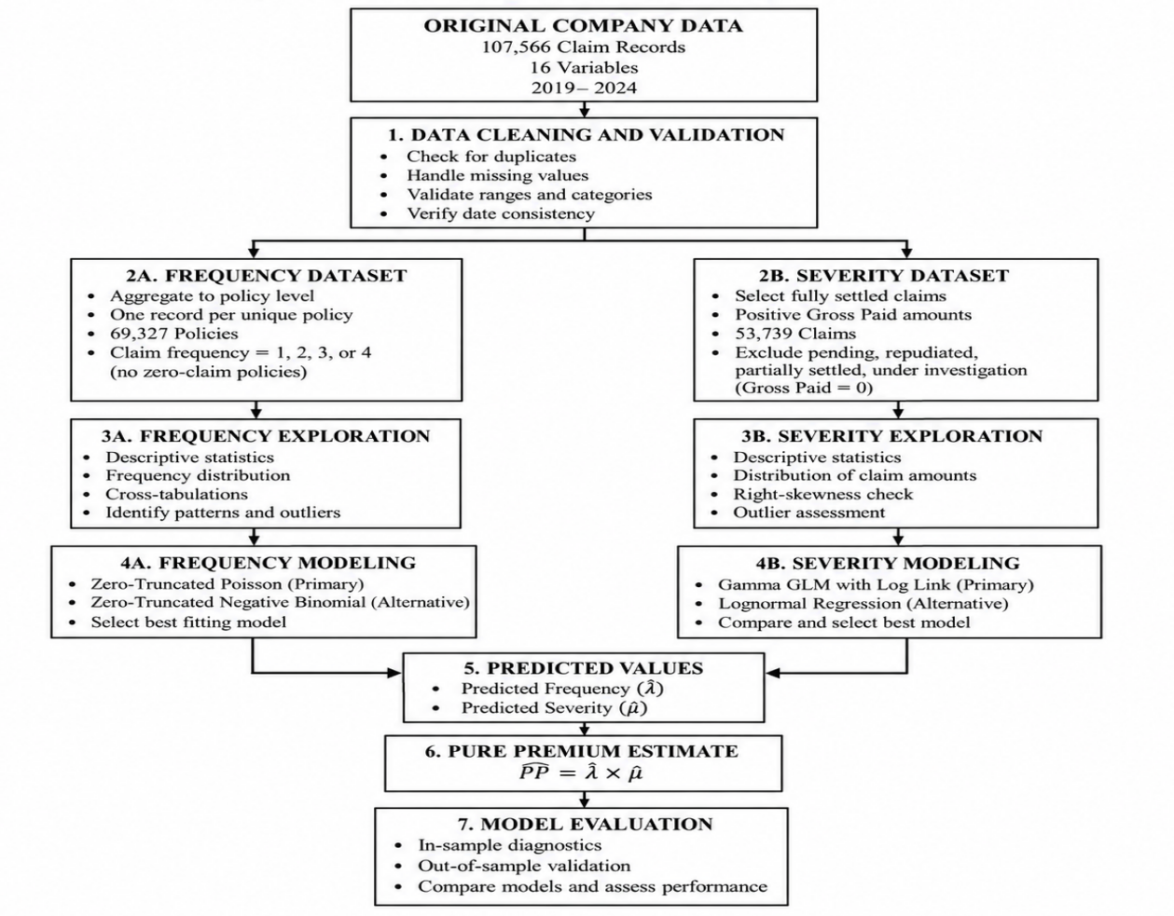
Figure 1: Data Preparation and Analysis Workflow

3.5 Ethical Considerations and Confidentiality
The study uses secondary insurance data obtained from a private insurance company. Insurance records may contain confidential policyholder information and commercially sensitive information about the insurer. The data will therefore be handled in a manner that protects confidentiality and prevents identification of individual policyholders.
The identity of the insurance company is not disclosed due to lack of explicit permission. Policy IDs and claim numbers will be used only for data management, identification of repeated claims, and policy-level aggregation. These identifiers will not be reproduced in the final report.
No attempt will be made to identify individual policyholders from the available records. Results will be presented in aggregated form through descriptive statistics, regression coefficients, model-comparison measures, tables, and figures. The dataset will be used only for purposes related to this academic actuarial project.

3.6 Description of the Frequency Model
Claim frequency is a count outcome. Standard count distributions include the Poisson and Negative Binomial distributions. However, the available dataset contains only positive claim counts because every observed policy has experienced at least one claim. A zero-truncated count model is therefore required.

3.6.1 Zero-Truncated Poisson Model
For an ordinary Poisson random variable (N_i^*),
fₙ(n) = e⁻λᵢ λᵢⁿ / n!, n = 0, 1, 2, …
with:
E(Nᵢ*) = λᵢ
and:
Var (Nᵢ*) = λᵢ
In the present study, only policies satisfying:
$$N_{i}>0$$
are observed. The probability function must therefore be conditioned on the event that at least one claim has occurred:
P(Nᵢ = n) / [1 − P(Nᵢ = 0)]
For the Poisson distribution, this becomes:
fₙ(n) = e⁻λᵢ λᵢⁿ / {n! (1 − e⁻λᵢ)}, n = 1, 2, …
The expected underlying claim-frequency parameter is linked to the selected explanatory variables using a logarithmic link:
ηᵢ = β₀ + β₁X₁ᵢ + β₂X₂ᵢ + ⋯ + βₚXₚᵢ
The initial frequency-model specification is:
log(λᵢ) = β₀ + β₁(Driver Ageᵢ) + β₂(Vehicle Ageᵢ) + β₃(Vehicle Typeᵢ) + β₄(Vehicle Valueᵢ) + β₅(Locationᵢ)
Under the logarithmic link, exponentiating a regression coefficient gives a multiplicative interpretation. For a continuous predictor, exp(βₖ) represents the multiplicative change in the underlying expected claim-frequency parameter associated with a one-unit increase in that variable, holding the other predictors constant.

3.6.2 Alternative Frequency Model
A Zero-Truncated Negative Binomial model will be considered as an alternative to the Zero-Truncated Poisson model. Negative Binomial distribution allows additional variability through a dispersion parameter. A common variance specification is:
Var(Nᵢ) = μᵢ + αμᵢ²
where α represents the dispersion parameter.
The alternative model will be evaluated only if the fitted data indicates that additional dispersion flexibility improves model performance. Selection between the Zero-Truncated Poisson and Zero-Truncated Negative Binomial models will therefore be based on model fit, diagnostics, and predictive performance rather than assuming that one distribution is automatically superior.

3.7 Description of the Severity Model
Claim severity is measured using Gross Paid for fully settled claims. These values are positive and expected to exhibit right-skewness, which is common in insurance loss data.

3.7.1 Gamma Generalized Linear Model
The primary severity model will be a Gamma Generalized Linear Model with a logarithmic link.
Let (Yj) represent the Gross Paid amount for settled claim (j). The model assumes:
Yⱼ ~ Gamma(μⱼ, φ)
with:
E(Yⱼ) = μⱼ
and:
Var(Yⱼ) = φμⱼ²
The mean severity is related to explanatory variables through:
ηⱼ = α₀ + α₁Z₁ⱼ + ⋯ + αqZqⱼ
The proposed model is:
log(μⱼ) = α₀ + α₁(Driver Ageⱼ) + α₂(Vehicle Ageⱼ) + α₃(Vehicle Typeⱼ) + α₄(Sum Insuredⱼ) + α₅(Locationⱼ) + α₆(Loss Yearⱼ)
The log link guarantees positive predicted severity:
μ̂ⱼ > 0
This is appropriate because expected claim payments cannot be negative.

3.7.2 Lognormal Comparison Model
A Lognormal regression model will be fitted as an alternative severity model. This distribution is also appropriate for positive right-skewed claim amounts.
The model assumes:
log(Yⱼ) = α₀ + α₁Z₁ⱼ + ⋯ + αqZqⱼ + εⱼ
where:
εⱼ ~ N(0, σ²)
Predictions will be returned to the original monetary scale. Under the standard Lognormal assumption:
exp(ηⱼ + σ²/2)
where ηⱼ represents the fitted linear predictor.
The Gamma and Lognormal models will be compared using predictive accuracy and diagnostic performance. The better-performing severity specification will be used in the final pure-premium calculation.

3.8 Frequency-Severity Pure Premium Model
The central actuarial framework of the study combines expected claim frequency and expected claim severity.
Let total claims cost for policy (i) be:
Sᵢ = Σⱼ₌₁ᴺⁱ Xᵢⱼ
where Nᵢ represents the number of claims and Xᵢⱼ represents the financial severity of claim j.
Under the basic frequency-severity assumption that claim frequency and claim severity are conditionally independent after accounting for the included risk characteristics:
E(Sᵢ) = E(Nᵢ) × E(Xᵢ)
The estimated pure premium is consequently:
PP̂ᵢ = λ̂ᵢ × μ̂ᵢ
where:
predicted expected claim frequency
and:
predicted expected claim severity
The estimated pure premium represents the expected claims cost associated with a risk profile. It does not represent the complete commercial premium because operating expenses, commissions, taxes, reinsurance costs, profit margins, and other premium loadings are not included.
The complete modelling framework is summarized in Figure 3.2. 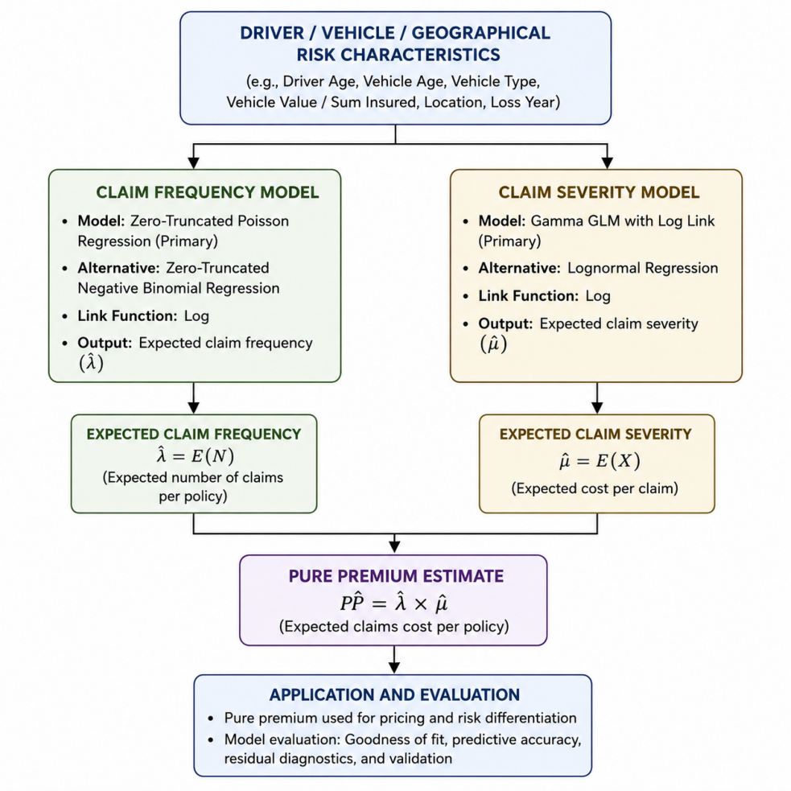

Figure 2: Frequency-Severity Framework for Pure Premium Estimation

3.9 Summary of Proposed Models
Component | Response | Primary Model | Comparison Model | Main Purpose
Claim Frequency | Number of claims per policy | Zero-Truncated Poisson regression | Zero-Truncated Negative Binomial | Estimate expected claim frequency
Claim Severity | Gross Paid on settled claims | Gamma GLM with log link | Lognormal regression | Estimate expected claim amount
Pure Premium | Expected claims cost | Frequency × Severity | — | Estimate risk-differentiated pure premium
Table 6: Summary of the Statistical Modelling Framework

3.10 Model Assumptions
The proposed framework is based on several assumptions that are necessary for estimation and interpretation.
First, the observed positive claim counts are assumed to arise from an underlying count process that can reasonably be represented using a zero-truncated Poisson distribution. This assumption will be evaluated through model diagnostics and comparison with a zero-truncated Negative Binomial alternative.
Second, because policy exposure information is unavailable, the analysis assumes that the observed policies have broadly comparable exposure over the period represented by the claim-frequency variable. Consequently, no exposure offset will be included in the primary frequency model. This assumption limits interpretation of frequency because differences in insured duration cannot be directly controlled.
Third, fully settled Gross Paid amounts are assumed to provide a reasonable representation of realized claim severity. Claims that remain pending, under investigation, repudiated, or partially settled are excluded from the primary severity analysis because their observed payment amounts may not represent completed claim costs.
Fourth, the frequency-severity premium calculation assumes conditional independence between claim frequency and claim severity after accounting for the included risk characteristics. This simplifies the expected aggregate loss to the product of expected frequency and expected severity. Previous research has shown that dependence may exist between these components; therefore, the assumption will be acknowledged when interpreting the results.
Fifth, the included driver, vehicle, and geographical variables are assumed to capture part of the systematic variation in claim experience. Important variables that are unavailable, such as exact policy exposure, driving experience, annual mileage, no-claim discount, policy excess, detailed coverage, and other behavioral factors, cannot be incorporated.
Finally, the company's claims experience is assumed to be sufficiently reliable for the purpose of demonstrating the proposed actuarial framework. The results will nevertheless be interpreted primarily as evidence from the available insurer rather than as estimates representing every motor insurer or policyholder in Kenya.

3.11 Model Estimation and Evaluation
The statistical analysis will be conducted using R statistical software. R is suitable for the study because it provides procedures for data manipulation, descriptive analysis, zero-truncated count regression, Generalized Linear Models, Lognormal regression, diagnostic analysis, prediction, and graphical presentation.
The complete R script used to implement the analysis will be provided in the appendix rather than reproduced throughout the methodology chapter. Chapter Three describes the statistical procedures and mathematical models, while the appendix provides the detailed code required to reproduce the analysis.
The analysis will proceed sequentially. First, the dataset will be imported, cleaned, and validated. Separate frequency and severity datasets will then be created. Exploratory analysis will be performed to examine the distributions of claim frequency, claim severity, and explanatory variables.
The candidate frequency models will subsequently be estimated and evaluated. The primary Zero-Truncated Poisson model will be compared with the Zero-Truncated Negative Binomial alternative where appropriate. The Gamma GLM will then be fitted to the severity data and compared with the Lognormal model.
Where practical, approximately 80% of the observations will be used for model development and 20% for validation. The data partition will be undertaken at policy level where necessary so that observations associated with the same policy are not unnecessarily divided between the training and validation samples.
Frequency models will be evaluated using measures including log-likelihood, Akaike Information Criterion where models are directly comparable, residual diagnostics, observed-versus-predicted claim counts, and predictive error.
Severity models will be compared using predictions expressed on the original monetary scale. Predictive performance will be measured using Mean Absolute Error and Root Mean Squared Error.
Mean Absolute Error is defined as:
MAE = (1/n) Σᵢ₌₁ⁿ |Yᵢ − Ŷᵢ|
while Root Mean Squared Error is:
RMSE = √[(1/n) Σᵢ₌₁ⁿ (Yᵢ − Ŷᵢ)²]
Lower values of these measures indicate smaller prediction errors..
Model interpretation will consider statistical significance, estimated effect size, predictive performance, residual behaviour, and actuarial plausibility. A predictor will therefore not be evaluated solely based on its p-value; its practical relationship with motor insurance risk will also be considered.
Following model selection, predicted claim frequency and predicted claim severity will be combined to obtain pure-premium estimates. Representative risk profiles will then be examined to demonstrate how differences in observable characteristics translate into differences in expected claims costs.

3.12 Methodological Limitations Arising from the Data
The principal limitation of the frequency analysis is the absence of policies with zero claims. The Zero-Truncated Poisson model accounts statistically for the fact that only positive counts are observed, but the lack of non-claimant policies limits direct validation of predicted claim occurrence across the insurer's full policy portfolio.
A second important limitation is the absence of explicit policy exposure. Claim frequency is normally expressed relative to policy-years or another exposure measure. Since this information is unavailable, comparable exposure must be assumed, and the resulting frequency estimates should be interpreted cautiously.
The severity analysis is limited by the presence of unresolved claims and the absence of outstanding claim reserves or ultimate incurred losses. Restricting the primary severity analysis to fully settled claims improves the interpretation of Gross Paid but may introduce differences between settled claims and claims that remain open for longer periods.
The dataset is also derived from one Kenyan insurer. The models therefore reflect the claims experience represented in that company's data and cannot automatically be generalized to the entire Kenyan motor insurance market. Other insurers may differ in underwriting practices, policyholder mix, geographic coverage, claims management, policy conditions, and risk characteristics.
Finally, some potentially important rating variables are unavailable. These include policy duration, driving experience, annual mileage, no-claim discount history, detailed coverage, policy excess, and other behavioral or underwriting information. Their absence may leave some variation in frequency and severity unexplained.
Despite these limitations, the dataset remains relevant to the objectives of the project because it contains a large number of actual motor insurance claims, identifiable policy-level claim counts, monetary claim information, and several actuarially meaningful risk characteristics. The proposed methodology therefore seeks to obtain the maximum useful information from the available data while explicitly recognizing the boundaries within which the resulting conclusions should be interpreted.

Chapter 4

DATA ANALYSIS AND RESULTS

4.1 Introduction
This chapter presents the results obtained from implementing the frequency-severity methodology described in Chapter Three. It begins with a brief summary of the analytical datasets and descriptive statistics, followed by the results of the claim-frequency and claim-severity models, model comparisons and diagnostics, and the estimation of risk-differentiated pure premiums.

4.2 Data Preparation Results
Following the data-selection procedures described in Chapter Three, the original dataset of 107,566 claim records was separated into datasets appropriate for frequency and severity modelling. Aggregating the claim records to policy level produced 69,327 unique claimant policies for frequency analysis, while restricting the severity analysis to fully settled claims with positive payments produced 53,739 claim observations. Missing settlement information was concentrated among unresolved or zero-paid claims and was therefore addressed through the severity-selection criteria rather than through general deletion of records. No additional exclusions for invalid chronological records are reflected in the final analytical sample sizes.
Analytical Stage | Number of Observations | Purpose
Original claims dataset | 107,566 | Initial company claims records
Frequency dataset | 69,327 policies | Claim-frequency modelling
Severity dataset | 53,739 claims | Claim-severity modelling
Table 7: Summary of Data Preparation and Analytical Samples

4.3 Descriptive Analysis of Claim Frequency
The frequency dataset contained 69,327 claimant policies, with observed claim counts ranging from one to four claims per policy. The mean claim frequency was approximately 1.552 claims per policy, with a variance of 0.749 and a standard deviation of 0.865. The absence of zero-claim observations reflects the claims-based structure of the available data.
Most policies recorded only one claim. Specifically, 44,986 policies (64.89%) had one claim, 13,930 (20.09%) had two claims, 6,924 (9.99%) had three claims, and 3,487 (5.03%) had four claims. The distribution therefore shows a concentration at lower positive claim counts, with progressively fewer policies experiencing multiple claims.
Statistic | Value
Number of policies | 69,327
Mean | 1.552
Variance | 0.749
Standard deviation | 0.865
Minimum | 1
Maximum | 4
Table 8: Descriptive Statistics for Claim Frequency
Number of Claims | Number of Policies | Percentage (%)
1 | 44,986 | 64.89
2 | 13,930 | 20.09
3 | 6,924 | 9.99
4 | 3,487 | 5.03
Total | 69,327 | 100.00

Table 9: Distribution of Claim Frequency Among Claimant Policies

Figure 3: Distribution of Claim Frequency Among Claimant Policies

4.4 Descriptive Analysis of Claim Severity
The severity analysis was based on 53,739 fully settled claims with positive Gross Paid amounts. The mean claim severity was approximately KES 410,921, while the median was substantially lower at KES 198,035. Claim amounts ranged from KES 8,011 to KES 2,998,426, with the first and third quartiles equal to approximately KES 105,147 and KES 516,030, respectively. The standard deviation was approximately KES 508,392, indicating considerable variation in claim amounts.
The distribution was strongly right-skewed, with a skewness coefficient of approximately 2.42. The coefficient of variation was approximately 1.24, showing that the standard deviation exceeded the mean and confirming substantial variability in claim severity. The large difference between the mean and median, together with the positive skewness, indicates that most settled claims were relatively moderate in size while a smaller number of high-cost claims extended the upper tail of the distribution. This pattern supports the consideration of positively skewed severity models such as the Gamma and Lognormal distributions.

Statistic | Gross Paid (KES)
Number of claims | 53,739
Mean | 410,920.60
Median | 198,035.00
Standard deviation | 508,391.60
Minimum | 8,011.00
First quartile (Q1) | 105,147.00
Third quartile (Q3) | 516,030.00
Maximum | 2,998,426.00
Coefficient of variation | 1.24
Skewness | 2.42
Table 10: Descriptive Statistics for Severity

Figure 4: Distribution of Gross Paid for Settled Claims

Figure 5: Boxplot of Gross Paid for Settled Claims

4.5 Descriptive Analysis of Explanatory Variables
The main explanatory variables considered in the modelling framework included driver age, vehicle age, vehicle value, sum insured, vehicle type, and location. At policy level, the average driver age was approximately 48.98 years, while the average vehicle age was 5.46 years. The mean vehicle value was approximately KES 3.68 million, and the average sum insured was approximately KES 2.87 million. Considerable variation was observed in both vehicle value and sum insured, reflecting differences in the financial value of the insured risks.
Among the categorical variables, Saloon vehicles were the most common vehicle type, accounting for 30.18% of claimant policies, followed by SUVs/4WDs at 19.90%, Matatus/PSVs at 15.02%, and Pickups at 14.74%. Nairobi represented the largest geographical category, accounting for 24.39% of claimant policies, followed by Mombasa at 10.74%, Nakuru at 6.33%, and Kisumu at 6.09%. These differences in the composition of the insured risks provide useful context for interpreting the frequency and severity regression results presented in the subsequent sections.
Variable | Mean | Standard Deviation | Minimum | Q1 | Median | Q3 | Maximum
Driver Age (years) | 48.98 | 18.20 | 18 | 33 | 49 | 65 | 80
Vehicle Age (years) | 5.46 | 4.30 | 0 | 2 | 5 | 7 | 25
Vehicle Value (KES) | 3,681,998.56 | 2,793,010.46 | 500,166 | 1,719,053.50 | 2,738,263 | 4,690,394 | 14,993,177
Sum Insured (KES) | 2,873,882.97 | 2,317,495.51 | 165,488 | 1,269,132 | 2,112,534 | 3,659,620 | 14,928,136
Table 11: Descriptive Summary of Rating Variables

CHAPTER FOUR

RESULTS AND FINDINGS

4.1 Introduction
This chapter presents the numerical results obtained from the frequency-severity modelling framework developed for the motor insurance claims data. In accordance with the methodology described in Chapter Three, claim frequency was analyzed using Zero-Truncated Poisson (ZTP) and Zero-Truncated Negative Binomial (ZTNB) regression models, while claim severity was analyzed using a Gamma generalized linear model (GLM) and a Lognormal regression model. The preferred frequency and severity models were then combined to estimate risk-differentiated pure premiums.
The results are presented using descriptive statistics, regression estimates, model-fit criteria, prediction-error measures, diagnostic plots, and pure-premium estimates. Tables and figures generated from the R analysis are incorporated at the relevant points to provide a clear presentation of the numerical findings.

4.2 Data Preparation Results
The original motor insurance claims dataset consisted of 107,566 claim records and 16 variables. For the claim-frequency analysis, the records were aggregated to policy level using the policy identifier. This produced 69,327 unique claimant policies. Since the available dataset consisted of claims records, every policy included in the frequency sample had at least one observed claim.
For claim-severity analysis, only claims classified as fully Settled and having a positive gross-paid value were retained. This produced a final severity sample of 53,739 settled claims. Claims classified as Pending, Repudiated, Under Investigation, or Partially Settled were excluded from the main severity model because their recorded payments did not necessarily represent final claim costs.
No missing values were identified in the variables used in the final severity model. The dates of loss for the severity sample extended from 1 January 2019 to 31 December 2024.
Analysis component | Number of observations | Unit of analysis
Original claims dataset | 107,566 | Claim
Frequency dataset | 69,327 | Policy
Severity dataset | 53,739 | Settled claim
Table 12: Summary of Analytical Samples

4.3 Descriptive Results for Claim Frequency
Observed claim frequency ranged from one to four claims per claimant policy. The mean claim frequency was approximately 1.552 claims, while the variance was approximately 0.749 and the standard deviation was approximately 0.865.
The distribution was concentrated strongly at one claim. Of the 69,327 claimant policies, 44,986 policies (64.89%) recorded one claim. A further 13,930 policies (20.09%) recorded two claims, 6,924 policies (9.99%) recorded three claims, and 3,487 policies (5.03%) recorded four claims.
Number of claims | Number of policies | Percentage
1 | 44,986 | 64.89
2 | 13,930 | 20.09
3 | 6,924 | 9.99
4 | 3,487 | 5.03
Total | 69,327 | 100.00

Table 13: Observed Claim Frequency Distribution
The absence of zero counts confirmed that an ordinary Poisson or Negative Binomial model without truncation would not correspond directly to the observed data structure. This supported the use of zero-truncated count models.

4.4 Descriptive Results for Claim Severity
The 53,739 fully settled claims showed substantial variability in claim amounts. Mean gross-paid claim severity was approximately KES 410,921, while the median was considerably lower at KES 198,035. The standard deviation was approximately KES 508,392, demonstrating considerable dispersion in claim costs.
Claim severity ranged from KES 8,011 to KES 2,998,426. The first quartile was KES 105,147, while the third quartile was KES 516,030. The coefficient of variation was 1.237, indicating that the standard deviation exceeded the mean. The estimated skewness coefficient was 2.416, confirming a strongly right-skewed severity distribution.
Statistic | Value
Number of settled claims | 53,739
Mean | KES 410,921
Median | KES 198,035
Standard deviation | KES 508,392
Minimum | KES 8,011
First quartile | KES 105,147
Third quartile | KES 516,030
Maximum | KES 2,998,426
Coefficient of variation | 1.237
Skewness | 2.416
Table 14: Descriptive Statistics for Settled Claim Severity

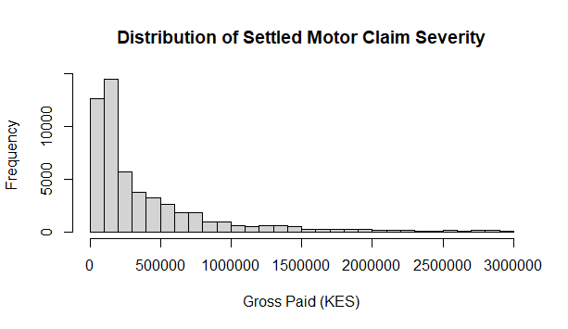
Figure 6: Distribution of Settled Motor Claim Severity
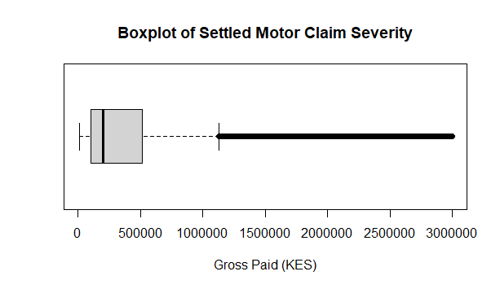
Figure 7: Boxplot of Settled Motor Claim Severity
Both figures confirm that the claim-cost distribution is concentrated at lower values with a comparatively long right tail. This supported the choice of positively skewed severity distributions such as Gamma and Lognormal models.

4.5 Descriptive Characteristics of the Explanatory Variables
At policy level, mean driver age was approximately 48.98 years, with values ranging from 18 to 80 years. Mean vehicle age was approximately 5.46 years, ranging from zero to 25 years. Mean vehicle value was approximately KES 3.68 million, while mean sum insured was approximately KES 2.87 million.
Saloon vehicles represented the largest category, with 20,923 policies (30.18%). This was followed by SUV/4WD vehicles with 13,797 policies (19.90%), Matatu/PSV with 10,412 (15.02%), and Pickup vehicles with 10,221 (14.74%).

Vehicle type | Policies | Percentage
Saloon | 20,923 | 30.18
SUV/4WD | 13,797 | 19.90
Matatu/PSV | 10,412 | 15.02
Pickup | 10,221 | 14.74
Minivan | 7,060 | 10.18
Truck/Lorry | 3,526 | 5.09
Bus | 2,022 | 2.92
Van | 1,366 | 1.97
Total | 69,327 | 100.00
Table 15: Distribution of Claimant Policies by Vehicle Type
Nairobi accounted for the largest number of claimant policies, followed by Mombasa, Nakuru, Kisumu, and Eldoret. Location was therefore retained as a categorical predictor in both modelling components.

4.6 Claim Frequency Model Results
The final ZTNB model was estimated using driver age, vehicle age, vehicle type, vehicle value, and location. After releveling the categorical variables for consistent interpretation, Saloon was used as the reference vehicle category and Nairobi as the reference location.
The model converged successfully after 52 BFGS optimization iterations. The estimated Negative Binomial theta parameter was 1.6693. The fitted log-likelihood remained approximately -69,937.01.
Driver age was not statistically significant, with an estimated coefficient of 0.0026 and p = .423. Vehicle age was similarly insignificant, with a coefficient of -0.0009 and p = .503. Vehicle value, measured per KES 1 million, had a coefficient of approximately 0.0020 and was also statistically insignificant (p = .664).
Among the vehicle categories, Minivan was the only category that differed significantly from Saloon at the 5% level. Its coefficient was 0.0511 (p = .0169), indicating a higher fitted claim-count intensity relative to Saloon vehicles, holding the other predictors constant. Exponentiating the coefficient gives approximately 1.052, corresponding to a modelled count parameter about 5.2% higher than that of the Saloon reference category.
Bus, Matatu/PSV, Pickup, SUV/4WD, Truck/Lorry, and Van were not statistically significant relative to Saloon. None of the locations were statistically significant at the 5% level compared with Nairobi. Eldoret showed weak evidence of a positive effect at the 10% level (p = .0956), but this did not meet the study's conventional 5% significance threshold.
Predictor | Estimate | Standard error | p-value
Driver age (per 10 years) | 0.0026 | 0.0033 | .423
Vehicle age | -0.0009 | 0.0014 | .503
Bus | 0.0436 | 0.0473 | .357
Matatu/PSV | 0.0212 | 0.0209 | .309
Minivan | 0.0511 | 0.0214 | .017
Pickup | 0.0163 | 0.0191 | .394
SUV/4WD | -0.0077 | 0.0275 | .780
Truck/Lorry | -0.0139 | 0.0463 | .764
Van | -0.0371 | 0.0447 | .407
Vehicle value (KES million) | 0.0020 | 0.0045 | .664
Table 16: Selected ZTNB Frequency-Model Estimates
Note. Saloon is the reference vehicle type and Nairobi is the reference location.
Overall, relatively few individual frequency predictors were statistically significant. This result was consistent with the narrow range of predicted frequencies obtained from the final model.

4.7 Frequency Model Comparison and Diagnostics
The ZTP model produced a log-likelihood of -70,597.73 and an AIC of 141,279.45. The ZTNB model produced a higher log-likelihood of approximately -69,937.01 and a lower AIC of 139,960.02.
Model | Log-likelihood | AIC | MAE | RMSE
Zero-Truncated Poisson | -70,597.73 | 141,279.45 | 0.7155 | 0.8651
Zero-Truncated Negative Binomial | -69,937.01 | 139,960.02 | 0.7155 | 0.8651
Table 17: Comparison of Frequency Models
The ZTNB model reduced AIC by approximately 1,319.43 points and increased log-likelihood by approximately 660.72 relative to the ZTP model. These results provided strong evidence that the ZTNB specification gave the better likelihood-based representation of the observed positive claim counts.
Point-prediction errors were almost identical. ZTP had an MAE of 0.7154565 and RMSE of 0.8651206, while ZTNB had an MAE of 0.7154557 and RMSE of 0.8651205. Thus, the improvement from ZTNB concerned distributional fit rather than a material improvement in fitted mean values. The selected ZTNB model produced predicted frequencies ranging from approximately 1.462 to 1.632, with a median of 1.550 and mean of 1.552.
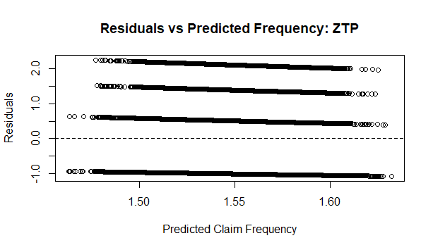
Figure 8: Residuals versus Predicted Claim Frequency: ZTP
Figure 9: Residuals versus Predicted Claim Frequency: ZTNB
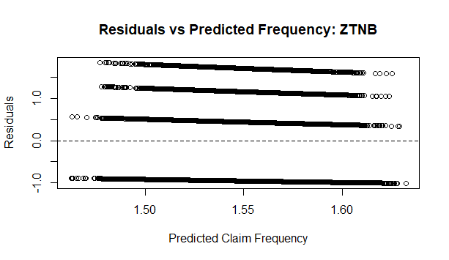
Figure 10: Residuals versus Predicted Claim Frequency: ZTNB
The residual plots displayed clear bands because the dependent variable consisted of only four discrete positive counts. ZTP residuals ranged from approximately -1.082 to 2.255, whereas ZTNB residuals ranged from approximately -1.011 to 1.849. Both models had residuals on either side of zero, although the ZTNB residual range was somewhat narrower. On the combined evidence from log-likelihood, AIC, and residual behaviour, the ZTNB model was retained as the final frequency model.

4.8 Claim Severity Model Results
The Gamma GLM was fitted to the 53,739 fully settled positive claims. The explanatory variables were driver age, vehicle age, vehicle type, sum insured, location, and loss year. Saloon was the reference vehicle category and Nairobi the reference location.
Vehicle age had a statistically significant negative coefficient of -0.0120 (p < .001). Under the log link, this implies that each additional year of vehicle age was associated with an approximately 1.2% decrease in expected claim severity, holding the other variables constant.
Sum insured, expressed in KES millions, had a significant positive coefficient of 0.0396 (p < .001). This corresponds to an estimated increase of approximately 4.0% in expected severity for each additional KES 1 million of sum insured, other characteristics held constant.
Several vehicle categories also differed significantly from Saloon. Bus had a coefficient of 0.1999 (p < .001), corresponding to expected severity approximately 22.1% higher than Saloon. Matatu/PSV had a coefficient of 0.1686, corresponding to approximately 18.4% higher expected severity. SUV/4WD had a coefficient of 0.2020, or approximately 22.4% higher, while Truck/Lorry had a coefficient of 0.1438, corresponding to approximately 15.5% higher expected severity.
Driver age was not statistically significant (p = .130). Minivan, Pickup, and Van also did not differ significantly from Saloon. Most individual location coefficients were statistically insignificant, and none of the loss-year coefficients from 2020 through 2024 differed significantly from the 2019 reference year.
Predictor | Estimate | Standard error | p-value
Driver age (per 10 years) | -0.0043 | 0.0028 | .130
Vehicle age | -0.0120 | 0.0013 | <.001
Bus | 0.1999 | 0.0386 | <.001
Matatu/PSV | 0.1686 | 0.0174 | <.001
Minivan | 0.0065 | 0.0185 | .724
Pickup | 0.0119 | 0.0163 | .465
SUV/4WD | 0.2020 | 0.0216 | <.001
Truck/Lorry | 0.1438 | 0.0363 | <.001
Van | 0.0273 | 0.0377 | .469
Sum insured (KES million) | 0.0396 | 0.0043 | <.001
Table 18: Selected Gamma GLM Severity-Model Estimates 1
Note. Saloon is the reference vehicle type and Nairobi is the reference location.
The Gamma model produced a mean predicted severity of approximately KES 411,096, which closely reproduced the observed severity mean of approximately KES 410,921.

4.9 Severity Model Comparison and Diagnostics
The Gamma GLM produced a log-likelihood of approximately -747,811.9 and an AIC of approximately 1,495,720. The Lognormal model, after calculating its likelihood on the original claim-cost scale, produced a higher log-likelihood of -744,904.4 and lower comparable AIC of 1,489,905.
However, predictive-error statistics on the original KES scale favoured the Gamma model.
Measure | Gamma GLM | Lognormal
Log-likelihood | -747,811.9 | -744,904.4
Comparable AIC | 1,495,720 | 1,489,905
MAE (KES) | 350,791.4 | 356,897.6
RMSE (KES) | 502,659.9 | 504,501.0
Mean predicted severity (KES) | 411,096 | 429,337
Table 19: Comparison of Severity Models
The Gamma GLM produced the lower MAE and RMSE and generated an overall mean prediction much closer to the observed mean severity. In contrast, the bias-adjusted Lognormal predictions had a mean of approximately KES 429,337, noticeably exceeding the observed mean.
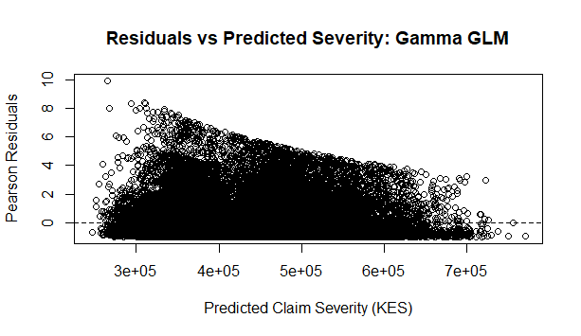
Figure 11: Residuals versus Predicted Claim Severity: Gamma GLM
Gamma Pearson residuals ranged from -0.9875 to 9.9230. The plot revealed remaining heterogeneity and several large positive residuals, particularly for claims whose observed costs substantially exceeded fitted values.
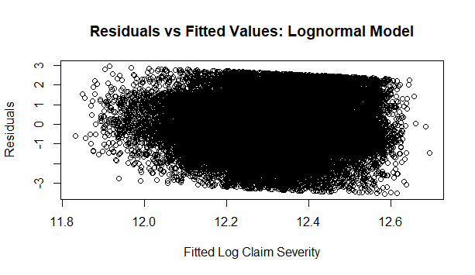
Figure 12: Residuals versus Fitted Values: Lognormal Model
Lognormal residuals ranged from approximately -3.550 to 2.964 and were more balanced around zero.
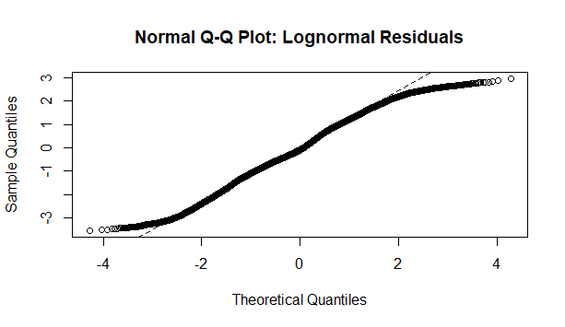
Figure 13: Normal Q-Q Plot of Log-normal Residuals
The Q-Q plot showed an approximately linear central region but clear curvature toward both tails. This indicated that the normality assumption for logged claim amounts was not fully satisfied.
Although the Lognormal model had superior likelihood-based fit, the objective of the study was prediction of expected claim cost on the original monetary scale. The Gamma GLM provided lower MAE and RMSE and more accurately reproduced the observed mean claim severity. Consequently, the Gamma GLM was retained as the final severity model.

4.10 Factors Influencing Claim Frequency and Severity
The modelling results demonstrated substantially greater risk differentiation in claim severity than in claim frequency.
For frequency, only the Minivan category differed significantly from the Saloon reference category at the 5% level. Driver age, vehicle age, vehicle value, the remaining vehicle categories, and all locations were insignificant at the 5% threshold. Predicted frequencies consequently occupied a relatively narrow range of approximately 1.462 to 1.632.
Severity displayed stronger relationships with observed risk characteristics. Vehicle age, sum insured, Bus, Matatu/PSV, SUV/4WD, and Truck/Lorry were statistically significant predictors of expected claim cost. In particular, differences between vehicle categories were materially larger in the severity component than in the frequency component.
The combined evidence therefore indicates that variation in estimated pure premium in the available data was driven primarily by claim severity rather than large differences in positive claim frequency.

4.11 Pure Premium Estimation
The selected ZTNB frequency model and Gamma severity model were combined using:
PP̂ᵢ = λ̂ᵢ × μ̂ᵢ
where λ̂ᵢ represents predicted claim frequency and μ̂ᵢ represents predicted claim severity.
The pure-premium calculation was applied to 69,327 claimant policy profiles. Mean predicted frequency was approximately 1.552, while mean predicted severity was approximately KES 410,951.
Estimated pure premiums ranged from approximately KES 384,630 to KES 1,186,221. The first quartile was approximately KES 546,984, the median was KES 592,221, and the third quartile was KES 721,507. The overall mean estimated pure premium was approximately KES 637,700.
Measure | Value
Number of claimant policies | 69,327
Mean predicted frequency | 1.552
Mean predicted severity | KES 410,951
Minimum pure premium | KES 384,630
First quartile | KES 546,984
Median | KES 592,221
Mean pure premium | KES 637,700
Third quartile | KES 721,507
Maximum pure premium | KES 1,186,221
Table 20: Summary of Estimated Pure Premiums
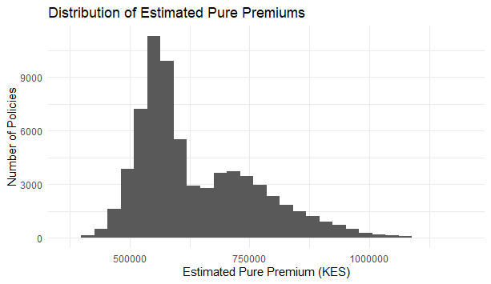
Figure 14: Distribution of Estimated Pure Premiums
The distribution confirms meaningful variation in expected claim cost across observed claimant profiles.

4.12 Pure Premium Differentiation Across Risk Profiles
Mean estimated pure premiums differed considerably across vehicle categories.
Vehicle type | Policies | Mean predicted frequency | Mean predicted severity (KES) | Mean pure premium (KES) | Median pure premium (KES)
Bus | 2,022 | 1.577 | 533,953 | 842,433 | 839,974
Truck/Lorry | 3,526 | 1.546 | 524,732 | 811,348 | 799,329
SUV/4WD | 13,797 | 1.545 | 500,012 | 772,657 | 770,568
Matatu/PSV | 10,412 | 1.559 | 443,045 | 690,590 | 694,676
Van | 1,366 | 1.525 | 369,864 | 564,033 | 565,746
Pickup | 10,221 | 1.554 | 361,684 | 562,091 | 565,216
Minivan | 7,060 | 1.574 | 352,939 | 555,464 | 558,850
Saloon | 20,923 | 1.544 | 351,518 | 542,831 | 545,961
Table 21: Estimated Pure Premiums by Vehicle Type
Bus vehicles had the highest mean pure premium, approximately KES 842,433, followed by Truck/Lorry at KES 811,348 and SUV/4WD at KES 772,657. Saloon vehicles had the lowest mean pure premium at approximately KES 542,831.
The differences were predominantly associated with severity. For example, mean predicted frequencies for Bus and Saloon were 1.577 and 1.544 respectively, whereas their mean predicted severities differed substantially at approximately KES 533,953 and KES 351,518 respectively. Location also produced some variation in estimated pure premiums.
Location | Policies | Mean frequency | Mean severity (KES) | Mean pure premium (KES)
Kisii | 1,925 | 1.567 | 426,179 | 668,062
Kitale | 1,909 | 1.582 | 421,780 | 667,164
Eldoret | 2,979 | 1.577 | 420,526 | 663,382
Marsabit | 1,250 | 1.529 | 433,681 | 663,173
Isiolo | 1,230 | 1.576 | 420,219 | 662,204
Nyeri | 1,930 | 1.561 | 421,939 | 658,783
Migori | 606 | 1.490 | 438,506 | 653,358
Embu | 1,259 | 1.574 | 415,071 | 653,309
Lamu | 1,237 | 1.543 | 421,730 | 650,609
Kisumu | 4,223 | 1.558 | 417,219 | 650,220

Table 22: Locations with the Highest Mean Estimated Pure Premiums
The complete 32-location output may be presented in the Appendix rather than the main chapter. The lowest-ten location table may also be placed in the Appendix to avoid overcrowding the main results section.
Three actual claimant-policy observations located close to the first quartile, median, and third quartile of the estimated pure-premium distribution were selected to demonstrate practical risk differentiation.
Profile | Driver age | Vehicle age | Vehicle type | Location | Sum insured (KES m) | Predicted frequency | Predicted severity (KES) | Pure premium (KES)
Lower-premium | 37 | 6 | Saloon | Mombasa | 1.50 | 1.538 | 355,749 | 546,981
Median-premium | 54 | 5 | Pickup | Lamu | 2.57 | 1.547 | 382,941 | 592,221
Higher-premium | 40 | 4 | Matatu/PSV | Isiolo | 2.87 | 1.583 | 455,735 | 721,501
Table 23: Representative Pure-Premium Profiles
These examples show that relatively modest differences in predicted positive claim frequency can combine with larger differences in expected severity to generate materially different pure-premium estimates.

4.13 Evaluation and Summary of Findings
The frequency-severity framework produced internally consistent and differentiated expected claim-cost estimates from the available motor insurance claims data. The ZTNB was selected as the preferred frequency model because it achieved a substantially lower AIC and higher log-likelihood than the ZTP model. Although predictive errors were almost identical, the ZTNB provided the better overall distributional fit.
The Gamma GLM was retained as the preferred severity model. Although the Lognormal specification achieved superior likelihood-based fit, the Gamma model produced lower MAE and RMSE and reproduced the observed average claim severity more accurately. These characteristics were particularly relevant because the primary purpose of the severity component was estimation of expected claim costs on the original KES scale.
The combined framework generated a mean estimated pure premium of approximately KES 637,700, with estimates ranging from approximately KES 384,630 to KES 1.19 million. Vehicle-type comparisons indicated that differences in expected severity contributed more strongly to premium differentiation than differences in predicted frequency.
The results should nevertheless be interpreted within the structure of the available data. The frequency dataset contained only policies associated with at least one claim and did not include zero-claim policies or policy exposure. Consequently, the estimated frequencies represent positive-claim experience among claimant policies and cannot be interpreted as unconditional annual claim frequencies for the insurer's complete portfolio. Similarly, the severity model was based only on fully settled claims because ultimate claim costs were unavailable for outstanding and partially settled claims.
Accordingly, the resulting estimates represent pure claim-cost estimates derived from the available claimant experience. They should not be interpreted as final commercial motor insurance premiums because the calculations do not include operating expenses, commissions, taxes, reinsurance costs, profit margins, or other premium loadings.
Overall, the numerical results demonstrate that a frequency-severity approach can provide an interpretable framework for differentiating expected motor insurance claim costs within the available Kenyan insurer claims experience. The selected ZTNB and Gamma models provide the basis for the conclusions and recommendations presented in Chapter Five.

CHAPTER FIVE

CONCLUSIONS AND RECOMMENDATIONS

5.1 Conclusions
This study developed and evaluated a frequency-severity framework for estimating motor insurance pure premiums using claims experience from a Kenyan insurer. Claim frequency was modelled using Zero-Truncated Poisson and Zero-Truncated Negative Binomial models, while claim severity was modelled using Gamma and Lognormal specifications.
The Zero-Truncated Negative Binomial model was selected as the preferred frequency model because it provided a better likelihood-based fit than the Zero-Truncated Poisson model. However, predicted claim frequencies varied only within a relatively narrow range, indicating limited differentiation in positive claim counts across the observed claimant profiles.
For claim severity, the Gamma GLM was retained because it produced lower MAE and RMSE and reproduced the observed mean claim severity more closely than the Lognormal model. Vehicle age, sum insured, and selected vehicle types were important determinants of severity.
Combining the selected frequency and severity models produced risk-differentiated pure-premium estimates with a mean of approximately KES 637,700. The results showed that differences in pure premium were driven more strongly by claim severity than by claim frequency.
The findings should be interpreted cautiously because the frequency dataset contained claimant policies only and did not include zero-claim policies or policy exposure. The resulting estimates therefore represent pure claim-cost estimates based on available claimant experience rather than full commercial premiums for the complete insured portfolio.

5.2 Recommendations
Insurers should consider separate modelling of claim frequency and claim severity when developing motor insurance pricing frameworks because the two components may respond differently to risk characteristics. Particular attention should be given to severity-related factors such as vehicle type, vehicle age, and sum insured, since these produced stronger differentiation in expected claim costs.
For practical pricing applications, insurers should maintain complete policy-level datasets that include both claimant and non-claimant policies together with accurate exposure information. This would allow estimation of unconditional annual claim frequencies and improve the reliability of portfolio-wide pure-premium estimates.
The models should also be reviewed periodically as new claims experience becomes available so that changes in risk patterns and claim costs can be incorporated into pricing decisions.

5.3 Areas for Future Research
Future research should extend the analysis using complete portfolio data containing zero-claim policies and policy exposure. This would permit direct modelling of annual claim frequency and produce more representative whole-portfolio premium estimates.
Further studies may also consider alternative severity distributions, dependence structures between frequency and severity, and more advanced modelling techniques such as generalized additive models, credibility models, or machine-learning approaches. Future work could also incorporate outstanding-claims development so that partially settled and unresolved claims can be included using estimated ultimate claim costs rather than being excluded from the severity analysis

References
Frees, E., Lee, G., & Yang, L. (2016). Multivariate Frequency-Severity regression models in insurance. Risks, 4(1), 4. https://doi.org/10.3390/risks4010004
Garrido, J., Genest, C., & Schulz, J. (2016). Generalized linear models for dependent frequency and severity of insurance claims. Insurance Mathematics and Economics, 70, 205–215. https://doi.org/10.1016/j.insmatheco.2016.06.006
Lee, W., Park, S. C., & Ahn, J. Y. (2018). Investigating dependence between frequency and severity via simple generalized linear models. Journal of the Korean Statistical Society, 48(1), 13–28. https://doi.org/10.1016/j.jkss.2018.07.003
Gilenko, E. V., & Mironova, E. A. (2017). Modern claim frequency and claim severity models: An application to the Russian motor own damage insurance market. Cogent Economics & Finance, 5(1), 1311097. https://doi.org/10.1080/23322039.2017.1311097
Su, X., & Bai, M. (2020). Stochastic gradient boosting frequency-severity model of insurance claims. PLoS ONE, 15(8), e0238000. https://doi.org/10.1371/journal.pone.0238000
Tevet, D. (2016). Applying Generalized Linear Models to Insurance Data: Frequency/Severity versus Pure Premium Modeling. In Cambridge University Press eBooks (pp. 39–59). https://doi.org/10.1017/cbo9781139342681.003
Covrig, M., & Badea, D. G. (2017). Some generalized linear models for the estimation of the mean frequency of claims in motor insurance. https://www.semanticscholar.org/paper/Some-Generalized-Linear-Models-for-the-Estimation-Covrig-Badea/6dca03d6ec9e12b06a8e86059bb64f6fb4fcdca7
Clemente, C., Guerreiro, G. R., & Bravo, J. M. (2023). Modelling motor insurance claim frequency and severity using gradient boosting. Risks, 11(9), 163. https://doi.org/10.3390/risks11090163
Association of Kenya Insurers. (2023). Insurance industry market report 2023. Association of Kenya Insurers. https://www.akinsure.com/content/uploads/documents/Insurance_Industry_Market_Report_2023
Association of Kenya Insurers. (2022). Insurance industry market report 2022. Association of Kenya Insurers. https://www.akinsure.com/content/uploads/documents/2022_AKI_Insurance_Industry_Report_Web_FINAL
Insurance Regulatory Authority. (2024). Insurance industry report for the period ended Q3 2024. Insurance Regulatory Authority. https://www.ira.go.ke/assets/file/4a19eaf8-quarter-3-2024-industry-release

APPENDIX A
R CODE FOR DATA PREPARATION AND ANALYSIS

A.1 PACKAGE INSTALLATION AND LOADING

install.packages("tidyverse")
install.packages("janitor")
install.packages("broom")
install.packages("e1071")

install.packages( "countreg",repos = "https://zeileis.R-universe.dev")

library(tidyverse)
library(janitor)
library(countreg)
library(broom)
library(ggplot2)
library(e1071)

A.2 DATA IMPORT AND INITIAL CLEANING
motor_raw <- read_csv(
"data/Kenya Motor Insurance Claims.csv"
)

dim(motor_raw)

motor_raw <- motor_raw |>
clean_names()

names(motor_raw)
glimpse(motor_raw)
summary(motor_raw)

n_distinct(motor_raw$policy_id)

A.3 FREQUENCY DATA PREPARATION

A.3.1 Create policy-level frequency dataset
frequency_data <- motor_raw |>
group_by(policy_id) |>
summarise(
claim_frequency = first(claim_freq),
driver_age = first(driver_age),
vehicle_age = first(vehicle_age),
vehicle_type = first(vehicle_type),
vehicle_value = first(vehicle_value),
location = first(location),
.groups = "drop"
)

A.3.2 Verify policy-level claim frequency

check_frequency <- motor_raw |>
dplyr::count(
policy_id,
name = "actual_claim_rows"
) |>
dplyr::left_join(
frequency_data |>
dplyr::select(
policy_id,
claim_frequency
),
by = "policy_id"
)

table(
check_frequency$actual_claim_rows ==
check_frequency$claim_frequency
)

A.3.3 Descriptive checks for claim frequency

table(frequency_data$claim_frequency)

mean(frequency_data$claim_frequency)

var(frequency_data$claim_frequency)

sd(frequency_data$claim_frequency)

table(
frequency_data$claim_frequency == 0
)

min(frequency_data$claim_frequency)

A.3.4 Missing-value check

colSums(
is.na(
frequency_data |>
dplyr::select(
claim_frequency,
driver_age,
vehicle_age,
vehicle_type,
vehicle_value,
location
)
)
)

A.4 FREQUENCY PREDICTOR PREPARATION
frequency_data <- frequency_data |>
dplyr::mutate(
vehicle_type = factor(vehicle_type),
location = factor(location)
)

frequency_data$vehicle_type <- relevel(
frequency_data$vehicle_type,
ref = "Saloon"
)

frequency_data$location <- relevel(
frequency_data$location,
ref = "Nairobi"
)

frequency_data <- frequency_data |>
dplyr::mutate(
driver_age_10 = driver_age / 10,
vehicle_value_m = vehicle_value / 1000000
)

A.5 ZERO-TRUNCATED POISSON FREQUENCY MODEL
ztp_model <- countreg::zerotrunc(
claim_frequency ~
driver_age_10 +
vehicle_age +
vehicle_type +
vehicle_value_m +
location,
data = frequency_data,
dist = "poisson"
)

summary(ztp_model)

logLik(ztp_model)

AIC(ztp_model)

A.5.1 Extract coefficients and confidence intervals

beta <- coef(ztp_model)

vc <- ztp_model$vcov

se <- sqrt(
diag(vc)
)

z_value <- beta / se

p_value <- 2 * (
1 - pnorm(
abs(z_value)
)
)

lower_beta <- beta - 1.96 * se
upper_beta <- beta + 1.96 * se
rate_ratio <- exp(beta)
lower_rr <- exp(lower_beta)
upper_rr <- exp(upper_beta)

coef_table <- data.frame(
term = names(beta),
estimate = beta,
std_error = se,
z_value = z_value,
p_value = p_value,
rate_ratio = rate_ratio,
lower_95 = lower_rr,
upper_95 = upper_rr
)

results_table <- coef_table |>
dplyr::select(
term,
estimate,
std_error,
p_value,
rate_ratio,
lower_95,
upper_95
)

results_table_rounded <- results_table |>
dplyr::mutate(
dplyr::across(
where(is.numeric),
~ round(.x, 4)
)
)

A.5.2 Generate ZTP predictions
frequency_data$predicted_frequency <- predict(
ztp_model,
newdata = frequency_data,
type = "response"
)

summary(
frequency_data$predicted_frequency
)

A.5.3 Export ZTP results

write.csv(
results_table_rounded,
"Table_4_5_ZTP_results.csv",
row.names = FALSE
)

saveRDS(
ztp_model,
"ztp_frequency_model.rds"
)

A.6 ZERO-TRUNCATED NEGATIVE BINOMIAL MODEL
ztnb_model_final <- countreg::zerotrunc(
claim_frequency ~
driver_age_10 +
vehicle_age +
vehicle_type +
vehicle_value_m +
location,
data = frequency_data,
dist = "negbin"
)

summary(ztnb_model_final)

ztnb_model_final$theta

ztnb_model_final$SE.logtheta

logLik(ztnb_model_final)

AIC(ztnb_model_final)

A.6.1 Generate ZTNB predictions

frequency_data$predicted_frequency_ztnb <- predict(
ztnb_model_final,
newdata = frequency_data,
type = "response"
)

summary(
frequency_data$predicted_frequency_ztnb
)

A.7 FREQUENCY MODEL COMPARISON
mae_ztp <- mean(
abs(
frequency_data$claim_frequency -
frequency_data$predicted_frequency
)
)

rmse_ztp <- sqrt(
mean(
(
frequency_data$claim_frequency -
frequency_data$predicted_frequency
)^2
)
)

mae_ztnb <- mean(
abs(
frequency_data$claim_frequency -
frequency_data$predicted_frequency_ztnb
)
)

rmse_ztnb <- sqrt(
mean(
(
frequency_data$claim_frequency -
frequency_data$predicted_frequency_ztnb
)^2
)
)

frequency_model_comparison <- data.frame(
Model = c(
"Zero-Truncated Poisson",
"Zero-Truncated Negative Binomial"
),
Log_Likelihood = c(
as.numeric(
logLik(ztp_model)
),
as.numeric(
logLik(ztnb_model_final)
)
),
AIC = c(
AIC(ztp_model),
AIC(ztnb_model_final)
),
MAE = c(
mae_ztp,
mae_ztnb
),
RMSE = c(
rmse_ztp,
rmse_ztnb
)
)

frequency_model_comparison_rounded <-
frequency_model_comparison |>
dplyr::mutate(
Log_Likelihood = round(
Log_Likelihood,
2
),
AIC = round(
AIC,
2
),
MAE = round(
MAE,
4
),
RMSE = round(
RMSE,
4
)
)

write.csv(
frequency_model_comparison_rounded,
"Table_Frequency_Model_Comparison_Final.csv",
row.names = FALSE
)

A.7.1 Calculate model-fit differences

aic_difference <-
AIC(ztp_model) -
AIC(ztnb_model_final)

loglik_difference <-
as.numeric(
logLik(ztnb_model_final)
) -
as.numeric(
logLik(ztp_model)
)

aic_difference

loglik_difference

A.8 FREQUENCY MODEL DIAGNOSTICS
residuals_ztp <- residuals(
ztp_model
)

residuals_ztnb <- residuals(
ztnb_model_final
)

summary(residuals_ztp)

summary(residuals_ztnb)

A.8.1 ZTP residual plot

plot(
frequency_data$predicted_frequency,
residuals_ztp,
xlab = "Predicted Claim Frequency",
ylab = "Residuals",
main = "Residuals vs Predicted Frequency: ZTP"
)

abline(
h = 0,
lty = 2
)

A.8.2 ZTNB residual plot

plot(
frequency_data$predicted_frequency_ztnb,
residuals_ztnb,
xlab = "Predicted Claim Frequency",
ylab = "Residuals",
main = "Residuals vs Predicted Frequency: ZTNB"
)

abline(
h = 0,
lty = 2
)

A.8.3 Observed and predicted frequency summary

frequency_prediction_summary <- frequency_data |>
dplyr::group_by(
claim_frequency
) |>
dplyr::summarise(
policies = dplyr::n(),
mean_predicted_ztp =
mean(
predicted_frequency
),
mean_predicted_ztnb =
mean(
predicted_frequency_ztnb
),
.groups = "drop"
)

A.9 FINAL FREQUENCY MODEL
final_frequency_model <-
ztnb_model_final

frequency_data$final_predicted_frequency <-
frequency_data$predicted_frequency_ztnb

saveRDS(
final_frequency_model,
"final_frequency_model_ZTNB.rds"
)

write.csv(
frequency_data,
"frequency_data_final.csv",
row.names = FALSE
)

A.10 SEVERITY DATA PREPARATION
severity_data <- motor_raw |>
dplyr::filter(
claim_status == "Settled",
gross_paid > 0
)

nrow(severity_data)

dim(severity_data)

table(
severity_data$claim_status
)

summary(
severity_data$gross_paid
)

sum(
severity_data$gross_paid <= 0
)

# A.10.1 Check selected severity variables

colSums(
is.na(
severity_data |>
dplyr::select(
gross_paid,
driver_age,
vehicle_age,
vehicle_type,
sum_insured,
location,
date_of_loss
)
)
)

A.10.2 Convert date of loss

severity_data$date_of_loss <- as.Date(
severity_data$date_of_loss,
format = "%d/%m/%Y"
)

severity_data$loss_year <- as.integer(
format(
severity_data$date_of_loss,
"%Y"
)
)

range(
severity_data$date_of_loss
)

table(
severity_data$loss_year
)

A.10.3 Prepare severity predictors
severity_data <- severity_data |>
dplyr::mutate(
vehicle_type =
factor(vehicle_type),
location =
factor(location)
)

severity_data$vehicle_type <- relevel(
severity_data$vehicle_type,
ref = "Saloon"
)

severity_data$location <- relevel(
severity_data$location,
ref = "Nairobi"
)

severity_data$driver_age_10 <-
severity_data$driver_age / 10

severity_data$sum_insured_m <-
severity_data$sum_insured / 1000000

severity_data$loss_year_factor <-
factor(
severity_data$loss_year
)

A.11 SEVERITY DESCRIPTIVE ANALYSIS
severity_summary <- data.frame(
Statistic = c(
"Number of claims",
"Mean",
"Median",
"Standard deviation",
"Minimum",
"First quartile",
"Third quartile",
"Maximum"
),
Value = c(
nrow(severity_data),
mean(
severity_data$gross_paid
),
median(
severity_data$gross_paid
),
sd(
severity_data$gross_paid
),
min(
severity_data$gross_paid
),
quantile(
severity_data$gross_paid,
0.25
),
quantile(
severity_data$gross_paid,
0.75
),
max(
severity_data$gross_paid
)
)
)

skewness(
severity_data$gross_paid
)

severity_cv <-
sd(
severity_data$gross_paid
) /
mean(
severity_data$gross_paid
)

severity_cv

A.11.1 Severity histogram

hist(
severity_data$gross_paid,
breaks = 30,
main =
"Distribution of Settled Motor Claim Severity",
xlab =
"Gross Paid (KES)",
ylab =
"Frequency"
)

A.11.2 Severity boxplot

boxplot(
severity_data$gross_paid,
horizontal = TRUE,
main =
"Boxplot of Settled Motor Claim Severity",
xlab =
"Gross Paid (KES)"
)

A.11.3 Severity by loss year

severity_by_year <- severity_data |>
dplyr::group_by(
loss_year
) |>
dplyr::summarise(
Claims =
dplyr::n(),
Mean_Severity =
mean(gross_paid),
Median_Severity =
median(gross_paid),
.groups = "drop"
)

A.12 GAMMA SEVERITY MODEL
gamma_model <- glm(
gross_paid ~
driver_age_10 +
vehicle_age +
vehicle_type +
sum_insured_m +
location +
loss_year_factor,
data = severity_data,
family = Gamma(
link = "log"
)
)

summary(gamma_model)

AIC(gamma_model)

logLik(gamma_model)

A.12.1 Gamma predictions

severity_data$predicted_gamma <- predict(
gamma_model,
newdata = severity_data,
type = "response"
)

summary(
severity_data$predicted_gamma
)

A.12.2 Gamma MAE and RMSE

mae_gamma <- mean(
abs(
severity_data$gross_paid -
severity_data$predicted_gamma
)
)

rmse_gamma <- sqrt(
mean(
(
severity_data$gross_paid -
severity_data$predicted_gamma
)^2
)
)

mae_gamma

rmse_gamma

A.13 LOGNORMAL SEVERITY MODEL
severity_data$log_gross_paid <-
log(
severity_data$gross_paid
)

lognormal_model <- lm(
log_gross_paid ~
driver_age_10 +
vehicle_age +
vehicle_type +
sum_insured_m +
location +
loss_year_factor,
data = severity_data
)

summary(lognormal_model)

A.13.1 Bias-adjusted predictions

sigma2_lognormal <-
summary(
lognormal_model
)$sigma^2

severity_data$predicted_lognormal <- exp(
predict(
lognormal_model,
newdata = severity_data
) +
sigma2_lognormal / 2
)

summary(
severity_data$predicted_lognormal
)

A.13.2 Lognormal MAE and RMSE

mae_lognormal <- mean(
abs(
severity_data$gross_paid -
severity_data$predicted_lognormal
)
)

rmse_lognormal <- sqrt(
mean(
(
severity_data$gross_paid -
severity_data$predicted_lognormal
)^2
)
)

mae_lognormal

rmse_lognormal

A.14 COMPARABLE LOGNORMAL LIKELIHOOD AND AIC
lognormal_residuals <-
residuals(
lognormal_model
)

sigma_lognormal_mle <- sqrt(
mean(
lognormal_residuals^2
)
)

loglik_lognormal_original_mle <- sum(
dlnorm(
severity_data$gross_paid,
meanlog =
fitted(
lognormal_model
),
sdlog =
sigma_lognormal_mle,
log = TRUE
)
)

k_lognormal <-
length(
coef(
lognormal_model
)
) + 1

aic_lognormal_original_mle <-
-2 *
loglik_lognormal_original_mle +
2 *
k_lognormal

sigma_lognormal_mle

loglik_lognormal_original_mle

aic_lognormal_original_mle

A.15 SEVERITY MODEL COMPARISON

severity_model_comparison <- data.frame(
Model = c(
"Gamma GLM",
"Lognormal Regression"
),
Log_Likelihood = c(
as.numeric(
logLik(gamma_model)
),
loglik_lognormal_original_mle
),
AIC = c(
AIC(gamma_model),
aic_lognormal_original_mle
),
MAE = c(
mae_gamma,
mae_lognormal
),
RMSE = c(
rmse_gamma,
rmse_lognormal
)
)

severity_model_comparison_rounded <-
severity_model_comparison |>
dplyr::mutate(
Log_Likelihood =
round(
Log_Likelihood,
2
),
AIC =
round(
AIC,
2
),
MAE =
round(
MAE,
2
),
RMSE =
round(
RMSE,
2
)
)

write.csv(
severity_model_comparison_rounded,
"Table_Severity_Model_Comparison.csv",
row.names = FALSE
)

A.16 SEVERITY MODEL DIAGNOSTICS
gamma_residuals <- residuals(
gamma_model,
type = "pearson"
)

summary(
gamma_residuals
)

# A.16.1 Gamma residual plot

plot(
severity_data$predicted_gamma,
gamma_residuals,
xlab =
"Predicted Claim Severity (KES)",
ylab =
"Pearson Residuals",
main =
"Residuals vs Predicted Severity: Gamma GLM"
)

abline(
h = 0,
lty = 2
)

A.16.2 Lognormal residual plot

lognormal_residuals <-
residuals(
lognormal_model
)

summary(
lognormal_residuals
)

plot(
fitted(
lognormal_model
),
lognormal_residuals,
xlab =
"Fitted Log Claim Severity",
ylab =
"Residuals",
main =
"Residuals vs Fitted Values: Lognormal Model"
)

abline(
h = 0,
lty = 2
)

# A.16.3 Lognormal Q-Q plot

qqnorm(
lognormal_residuals,
main =
"Normal Q-Q Plot: Lognormal Residuals"
)

qqline(
lognormal_residuals,
lty = 2
)

A.17 FINAL SEVERITY MODEL
final_severity_model <-
gamma_model

severity_data$final_predicted_severity <-
severity_data$predicted_gamma

saveRDS(
final_severity_model,
"final_severity_model_Gamma.rds"
)

write.csv(
severity_data,
"severity_data_final.csv",
row.names = FALSE
)

A.18 PURE PREMIUM DATA PREPARATION
premium_data <- frequency_data

severity_policy_vars <- motor_raw |>
dplyr::group_by(
policy_id
) |>
dplyr::summarise(
sum_insured =
dplyr::first(
sum_insured
),
date_of_loss =
dplyr::first(
date_of_loss
),
.groups = "drop"
)

severity_policy_vars$date_of_loss <- as.Date(
severity_policy_vars$date_of_loss,
format = "%d/%m/%Y"
)

severity_policy_vars <- severity_policy_vars |>
dplyr::mutate(
sum_insured_m =
sum_insured / 1000000,
loss_year =
as.integer(
format(
date_of_loss,
"%Y"
)
),
loss_year_factor =
factor(
loss_year,
levels =
levels(
severity_data$loss_year_factor
)
)
)

premium_data <- premium_data |>
dplyr::left_join(
severity_policy_vars |>
dplyr::select(
policy_id,
sum_insured_m,
loss_year_factor
),
by = "policy_id"
)

premium_data$vehicle_type <- factor(
premium_data$vehicle_type,
levels =
levels(
severity_data$vehicle_type
)
)

premium_data$location <- factor(
premium_data$location,
levels =
levels(
severity_data$location
)
)

A.19 PURE PREMIUM PREDICTION
premium_data$predicted_frequency <- predict(
final_frequency_model,
newdata = premium_data,
type = "response"
)

premium_data$predicted_severity <- predict(
final_severity_model,
newdata = premium_data,
type = "response"
)

premium_data$pure_premium <-
premium_data$predicted_frequency *
premium_data$predicted_severity

summary(
premium_data$predicted_frequency
)

summary(
premium_data$predicted_severity
)

summary(
premium_data$pure_premium
)

sum(
premium_data$pure_premium <= 0
)

sum(
is.na(
premium_data$pure_premium
)
)

A.20 PURE PREMIUM SUMMARY TABLES
final_premium_summary <- data.frame(
Measure = c(
"Number of policies",
"Mean predicted frequency",
"Mean predicted severity",
"Minimum pure premium",
"First quartile pure premium",
"Median pure premium",
"Mean pure premium",
"Third quartile pure premium",
"Maximum pure premium"
),
Value = c(
nrow(premium_data),
mean(
premium_data$predicted_frequency
),
mean(
premium_data$predicted_severity
),
min(
premium_data$pure_premium
),
quantile(
premium_data$pure_premium,
0.25
),
median(
premium_data$pure_premium
),
mean(
premium_data$pure_premium
),
quantile(
premium_data$pure_premium,
0.75
),
max(
premium_data$pure_premium
)
)
)

A.20.1 Pure premium by vehicle type

premium_by_vehicle <- premium_data |>
dplyr::group_by(
vehicle_type
) |>
dplyr::summarise(
Policies =
dplyr::n(),
Mean_Frequency =
mean(
predicted_frequency
),
Mean_Severity =
mean(
predicted_severity
),
Mean_Pure_Premium =
mean(
pure_premium
),
Median_Pure_Premium =
median(
pure_premium
),
.groups = "drop"
) |>
dplyr::arrange(
dplyr::desc(
Mean_Pure_Premium
)
)

A.20.2 Pure premium by location

premium_by_location <- premium_data |>
dplyr::group_by(
location
) |>
dplyr::summarise(
Policies =
dplyr::n(),
Mean_Frequency =
mean(
predicted_frequency
),
Mean_Severity =
mean(
predicted_severity
),
Mean_Pure_Premium =
mean(
pure_premium
),
.groups = "drop"
) |>
dplyr::arrange(
dplyr::desc(
Mean_Pure_Premium
)
)

premium_by_location_final <-
premium_by_location |>
dplyr::mutate(
Mean_Frequency =
round(
Mean_Frequency,
3
),
Mean_Severity =
round(
Mean_Severity,
0
),
Mean_Pure_Premium =
round(
Mean_Pure_Premium,
0
)
)

premium_by_location_top10 <-
premium_by_location_final |>
dplyr::slice_head(
n = 10
)

premium_by_location_bottom10 <-
premium_by_location_final |>
dplyr::slice_tail(
n = 10
) |>
dplyr::arrange(
Mean_Pure_Premium
)

A.21 PURE PREMIUM FIGURES
hist(
premium_data$pure_premium,
breaks = 30,
main =
"Distribution of Estimated Pure Premiums",
xlab =
"Estimated Pure Premium (KES)",
ylab =
"Number of Policies"
)

boxplot(
pure_premium ~ vehicle_type,
data = premium_data,
las = 2,
xlab =
"Vehicle Type",
ylab =
"Estimated Pure Premium (KES)",
main =
"Estimated Pure Premium by Vehicle Type"
)

ggplot2::ggplot(
premium_data,
ggplot2::aes(
x = pure_premium
)
) +
ggplot2::geom_histogram(
bins = 30
) +
ggplot2::labs(
title =
"Distribution of Estimated Pure Premiums",
x =
"Estimated Pure Premium (KES)",
y =
"Number of Policies"
) +
ggplot2::theme_minimal()

A.22 REPRESENTATIVE PURE PREMIUM PROFILES
premium_targets <- quantile(
premium_data$pure_premium,
probs = c(
0.25,
0.50,
0.75
)
)

low_risk_profile <- premium_data |>
dplyr::mutate(
distance = abs(
pure_premium -
premium_targets[1]
)
) |>
dplyr::slice_min(
distance,
n = 1,
with_ties = FALSE
)

medium_risk_profile <- premium_data |>
dplyr::mutate(
distance = abs(
pure_premium -
premium_targets[2]
)
) |>
dplyr::slice_min(
distance,
n = 1,
with_ties = FALSE
)

high_risk_profile <- premium_data |>
dplyr::mutate(
distance = abs(
pure_premium -
premium_targets[3]
)
) |>
dplyr::slice_min(
distance,
n = 1,
with_ties = FALSE
)

risk_profiles <- dplyr::bind_rows(
Low = low_risk_profile,
Medium = medium_risk_profile,
High = high_risk_profile,
.id = "Risk_Profile"
)

risk_profiles_final <- risk_profiles |>
dplyr::select(
Risk_Profile,
driver_age,
vehicle_age,
vehicle_type,
vehicle_value,
location,
sum_insured_m,
loss_year_factor,
predicted_frequency,
predicted_severity,
pure_premium
) |>
dplyr::mutate(
predicted_frequency =
round(
predicted_frequency,
3
),
predicted_severity =
round(
predicted_severity,
0
),
pure_premium =
round(
pure_premium,
0
),
sum_insured_m =
round(
sum_insured_m,
2
)
)

A.23 EXPORT FINAL RESULTS
write.csv(
final_premium_summary,
"Final_Pure_Premium_Summary.csv",
row.names = FALSE
)

write.csv(
premium_by_vehicle,
"Final_Pure_Premium_by_Vehicle_Type.csv",
row.names = FALSE
)

write.csv(
premium_by_location_final,
"Final_Pure_Premium_by_Location.csv",
row.names = FALSE
)

write.csv(
premium_by_location_top10,
"premium_by_location_top10.csv",
row.names = FALSE
)

write.csv(
premium_by_location_bottom10,
"premium_by_location_bottom10.csv",
row.names = FALSE
)

write.csv(
risk_profiles_final,
"Representative_Risk_Profiles.csv",
row.names = FALSE
)

saveRDS(
premium_data,
"final_pure_premium_data.rds"
)

